**AP Chemistry Daily Videos: 6.9 Hess’s Law**

**Daily Video #1**

1. What does Hess’s Law look at? (Discuss steps in your answer.)

2. At 1:00, show how the single reaction of Cgraphite (s) 🡪 Cdiamond (s) can take place in two steps and result in the same ΔHrxn.

3. What happens to the ΔHrxn if a chemical reaction is reversed? (Provide an example.)

4. What happens to the ΔHrxn if you multiply a chemical reaction by a favor? (Provide an example.)

5. Pause the video at 2:45, attempt the problem, then evaluate how you did and identify any errors.

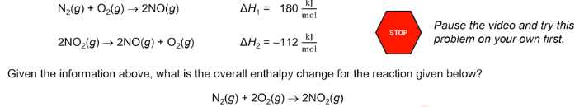

6. Key takeaways?

**AP Chemistry Daily Videos: 6.9 Hess’s Law**

**Daily Video #2**

1. Attempt this problem before watching. Look closely at the arrows and try to come up with your own answer before looking at the MC options.

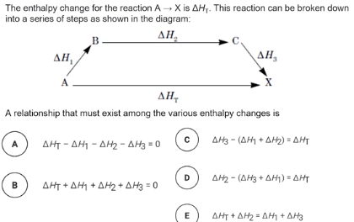

2. Pause the video at 2:00, attempt the problem, then evaluate how you did and identify any errors.

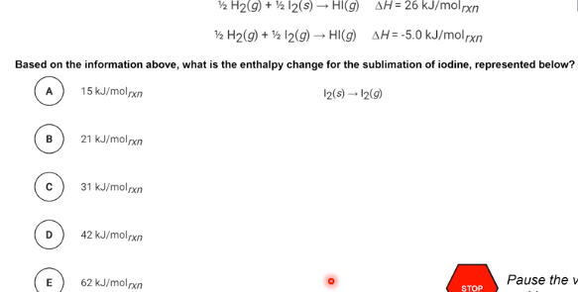

3. Pause the video at 3:55, attempt the problem, then evaluate how you did and identify any errors.

