**AP Chemistry Daily Videos**

[**7.14 Free Energy of Dissolution**](https://apclassroom.collegeboard.org/7/home)

[**Video #1**](https://apclassroom.collegeboard.org/7/home?apd=x72yh30cmp)

1. **Identify all the bonds/IMF involved when a salt dissolves in water.**

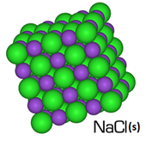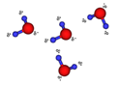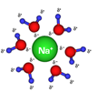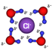



| **Bond/IMF (Identify the type)** | **Between what particles?** | **Is the Bond/IMF broken or released?** | **Is Energy required or released?** |
| --- | --- | --- | --- |
|  | **Water Molecules** |  |  |
|  | **Ions in the salt (Na-Cl)** |  |  |
|  | **Water and an ion** |  |  |

**Once you evaluate the energy required compared to the energy released you will better understand the enthalpy associated with dissolving this salt.**

1. **Use pictures to explain what entropy and microstates are.**
2. **Besides enthalpy what is the other factor needed to determine if a reaction is thermodynamically favorable? Write down the equation that combines these two factors.**