**AP Chemistry Daily Videos**

[**7.2 Direction of Reversible Reactions**](https://apclassroom.collegeboard.org/7/home)

[**Video #1**](https://apclassroom.collegeboard.org/7/home?apd=cm325y2il8)

1. **Draw a picture to represent the following:**

**Reactants or the reverse reaction are favored**

**Products of the forward reaction are favored**



1. **Try following the problem before the explanation and answer is given. If you got it wrong, what was your misunderstanding?**

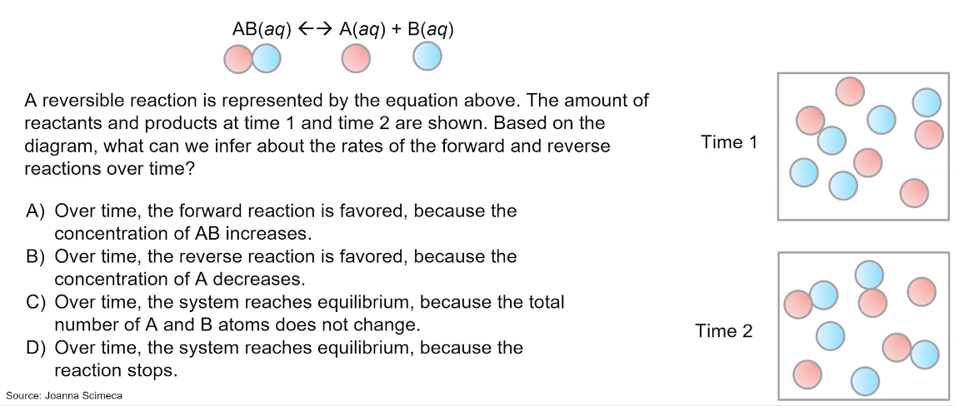

1. **Try following the problem before the explanation and answer is given. If you got it wrong, what was your misunderstanding?** 

