**AP Chemistry Daily Videos**

[**7.4 Calculating the Equilibrium Constant**](https://apclassroom.collegeboard.org/7/home)

[**Video #1**](https://apclassroom.collegeboard.org/7/home?apd=dycg0g1z9u)

1. **Describe what K is in your own way using the term ratio.**
2. **Under what conditions does K change?**
3. **How did you do with your calculations in example problem #1?**

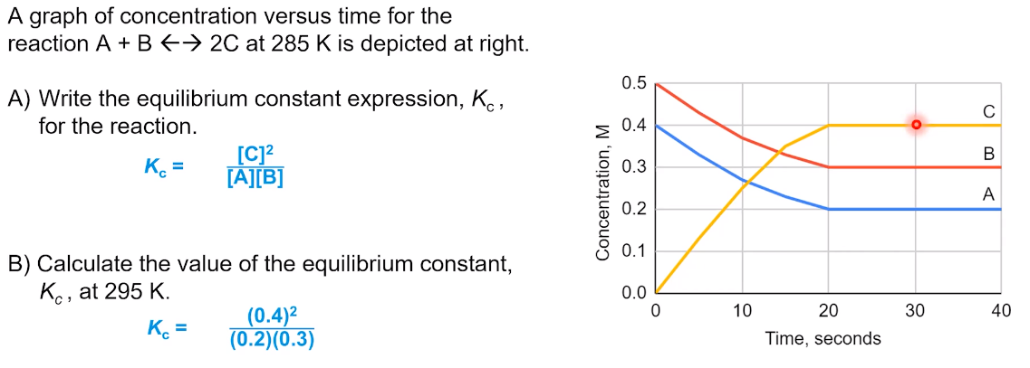

1. **There is an error in example 2. What is it?**

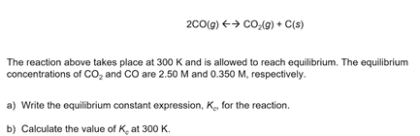

1. **Try following the problem before the explanation and answer is given. Evaluate how you did and identify any errors.**

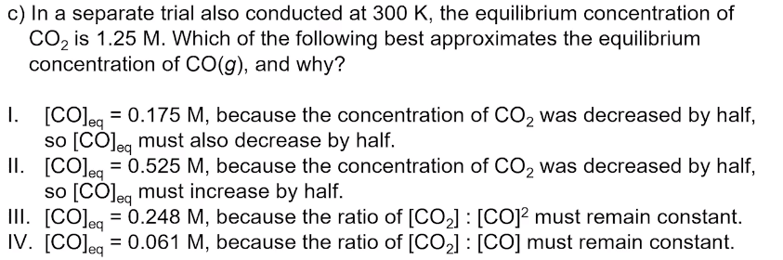

1. **What is the unit of K? Explain.**
2. **Evaluate your work in example problem #4?**
3. **Summarize key points for calculating K.**