**AP Chemistry Daily Videos**

[**8.4 Acid-Base Reactions and Buffers**](https://apclassroom.collegeboard.org/7/home)

[**Video #1**](https://apclassroom.collegeboard.org/7/home?apd=c4faqfrznu)

1. **Write down the generic formula for a neutralization reaction.**



1. **What is the net ionic equation for ALL strong acid and strong base reactions?**

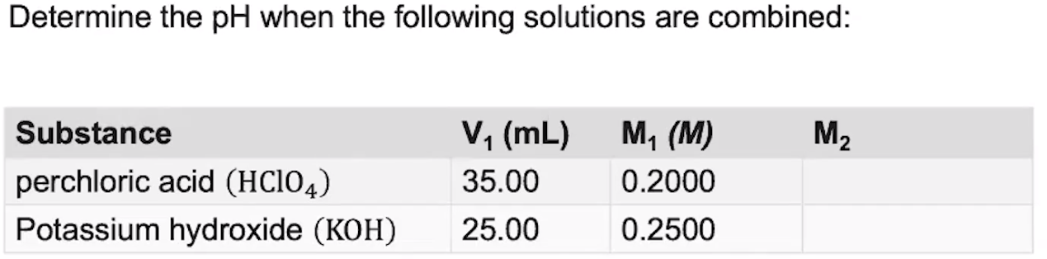

1. **Evaluate your ability to answer the question making sure you identify any errors.**
2. **Record what the instructor does and make sure you write down explanations for each step.**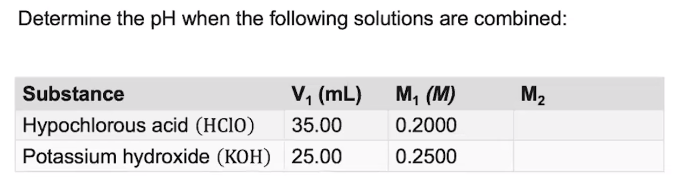
3. **If you didn’t get the correct answer, which step did your mistake begin and why was it a mistake?**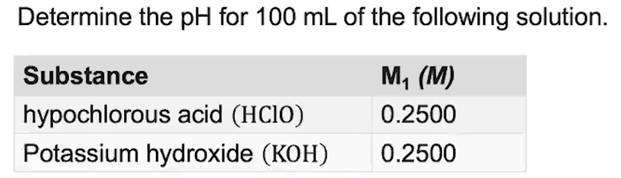
4. **What is the equivalency point?**

[**Video #2**](https://apclassroom.collegeboard.org/7/home?apd=vrlb8gm0ir)

1. **What is the half equivalency point?**
2. **What is true at the half equivalency point for a weak acid/strong base?**
3. **What is true at the half equivalence point for a strong acid/weak base?**
4. **What is a buffer solution? And what is a buffer’s function? Use the images below to guide you.**

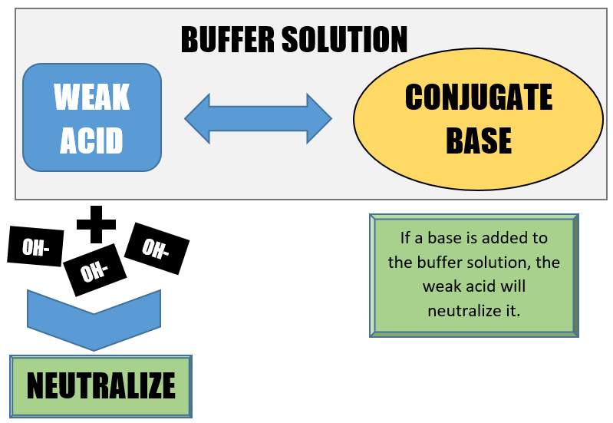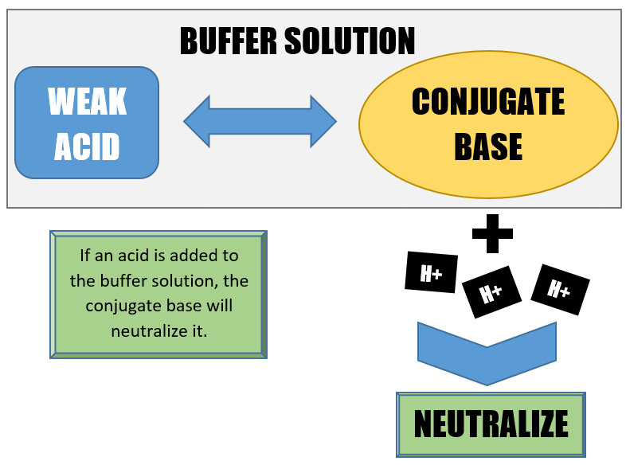

[**Video #3**](https://apclassroom.collegeboard.org/7/home?apd=subvp7o2yy)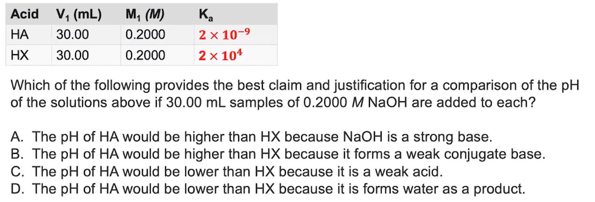

1. **If you didn’t get the correct answer, which step did your mistake begin and why was it a mistake?**
2. **Evaluate yourself.**