**AP Chemistry Daily Videos**

[**8.9 Henderson-Hasselbalch Equation**](https://apclassroom.collegeboard.org/7/home)

[**Video #1**](https://apclassroom.collegeboard.org/7/home?apd=aw7iabxtot)

1. **Identify the following in the reaction below: weak acid and conjugate base.**

**HA ↔ H+ + A-**

1. **What is the purpose of using the Henderson-Hasselbalch Equation?**
2. **Complete the table:**

|  | | |
| --- | --- | --- |
| **Concentrations** | **Is Log 0, neg, or positive?** | **What is the relationship of pH to pKa?** |
| **[HA]=[A-]** |  |  |
| **[A-]>[HA]** |  |  |
| **[A-]<[HA]** |  |  |

1. **Evaluate your work** 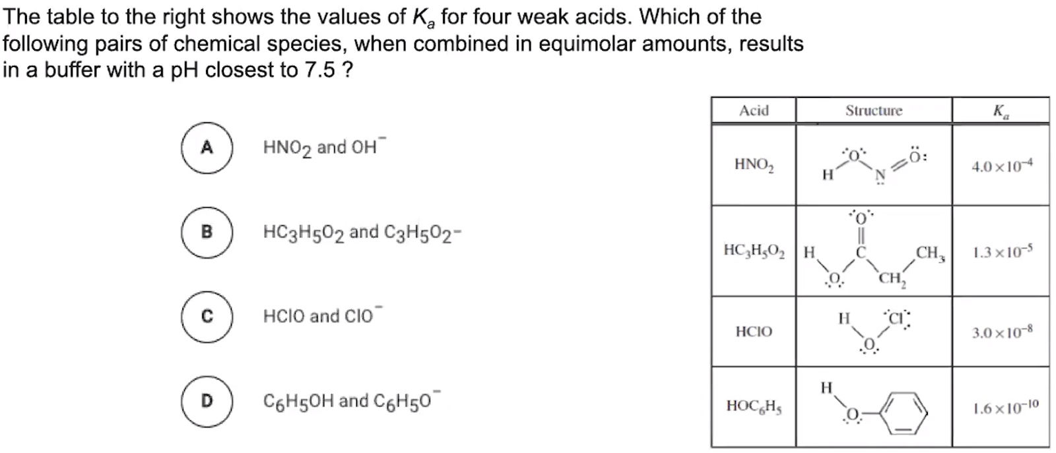

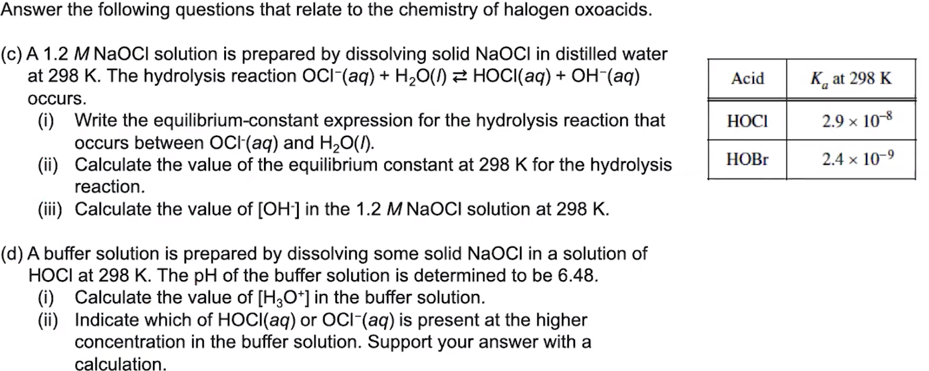

1. **Evaluate your work**