**AP Chemistry Daily Videos**

[**9.10 Electrolysis and Faraday’s Law**](https://apclassroom.collegeboard.org/7/home)

[**Video #1**](https://apclassroom.collegeboard.org/7/home?apd=vmdkjel92c)

1. **Identify each variable in the equation, what it means, and the units.**
2. **Try the problem on your own. Then evaluate your work and identify any errors you may have made.**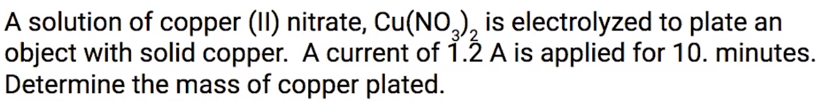

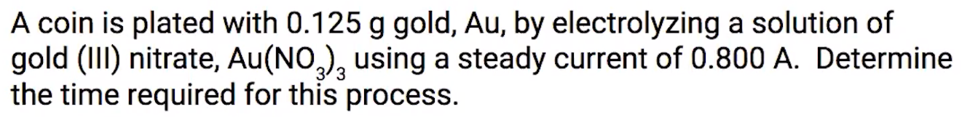

1. **Try the problem on your own. Then evaluate your work and identify any errors you may have made.**

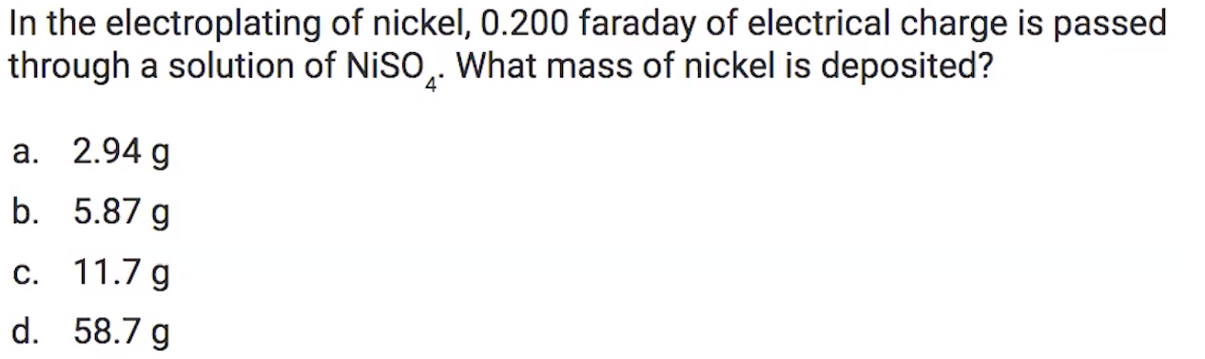

1. **Try the problem on your own. Then evaluate your work and identify any errors you may have made.**