**AP Chemistry Daily Videos**

**9.2 Absolute Entropy and Entropy Change**

[**Video #1**](https://apclassroom.collegeboard.org/d/jdhcy5wgh1?sui=7,9)

1. **What are the units for entropy values?**
2. **What is the equation used to calculate the entropy change of a process?**
3. **Pause the video @ 3:00 and try the problem on your own. Then evaluate your work and identify any errors you may have made.**

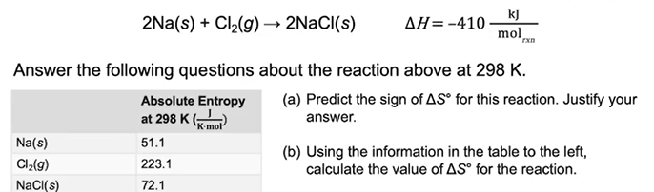

1. **What are the takeaways?**