**AP Chemistry Daily Videos**

[**9.4 Thermodynamic and Kinetic Control**](https://apclassroom.collegeboard.org/7/home)

[**Video #1**](https://apclassroom.collegeboard.org/7/home?apd=b3b56rdb20)

1. **Reactions that are thermodynamically favorable BUT have slow rates are under ______________ control. Generally, these reactions have _____________ activation energy.**

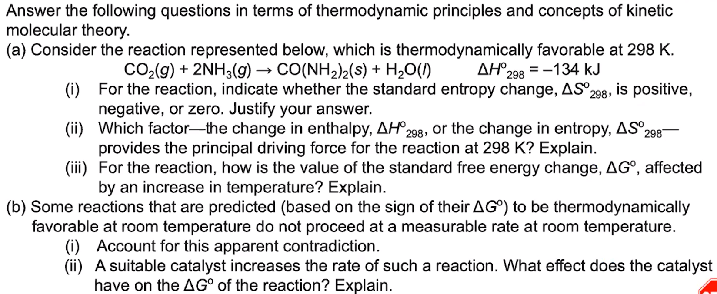

1. **Stop the video @ 3:32 and try the problem on your own. Then evaluate your work and identify any errors you may have made.**