**AP Chemistry Daily Videos**

[**9.5 Free Energy and Equilibrium**](https://apclassroom.collegeboard.org/7/home)

[**Video #1**](https://apclassroom.collegeboard.org/7/home?apd=zsy4czyybl)

1. **Relate ΔG° and K by completing the following table:** [**Khan Academy link**](https://www.khanacademy.org/science/ap-chemistry/thermodynamics-ap/gibbs-free-energy-tutorial-ap/v/standard-change-in-free-energy-and-the-equilibrium-constant)

| **Sign of ΔG° @ equilibrium** | **The sign of ΔG° indicates the reaction is spontaneous (thermodynamically favorable) or not spontaneous (not thermodynamically favorable)?** | **Product or Reactants Favored?**  **Note, if the reaction is a go and favorable then what would you have more of, products or reactants?** | **Describe K** |
| --- | --- | --- | --- |
| **ΔG° is negative** |  |  |  |
| **ΔG° is positive** |  |  |  |
| **ΔG°=zero** |  |  |  |

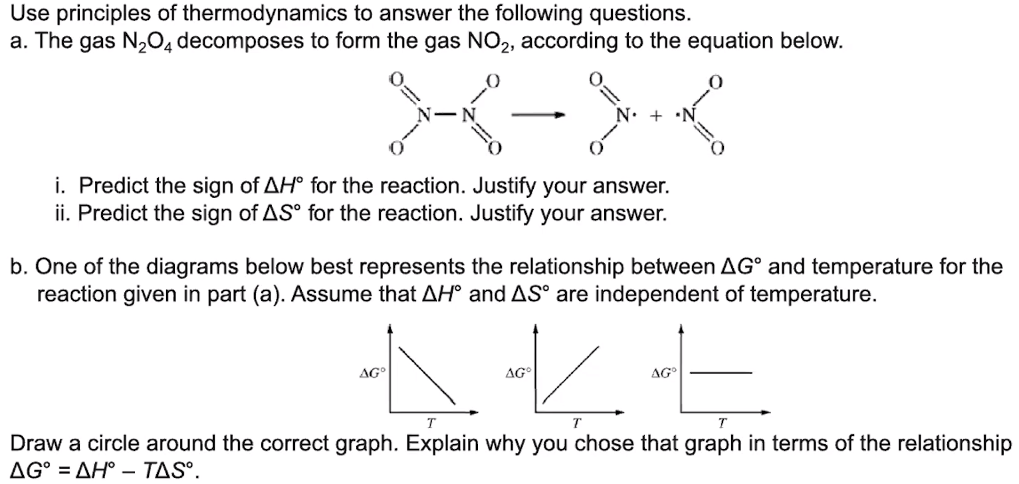

**2. Try the problem on your own. Then evaluate your work and identify any errors you may have made.**

