**AP Chemistry Daily Videos**

[**9.6 Coupled Reactions**](https://apclassroom.collegeboard.org/7/home)

[**Video #1**](https://apclassroom.collegeboard.org/7/home?apd=h5b8dyv1dm)

1. **What are two ways to *force* a thermodynamically unfavorable (ΔG=positive) reaction to occur?**
2. **What is meant by a coupled reaction?**

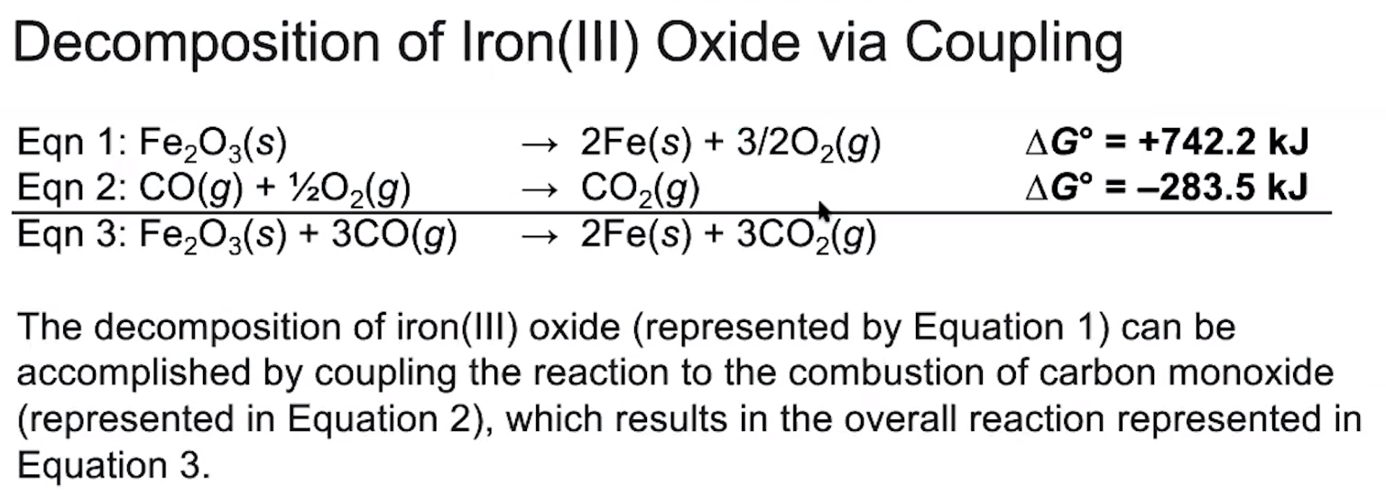

1. **Explain how you can use the technique of Hess’s Law to obtain an overall ΔG that is negative in this problem.**





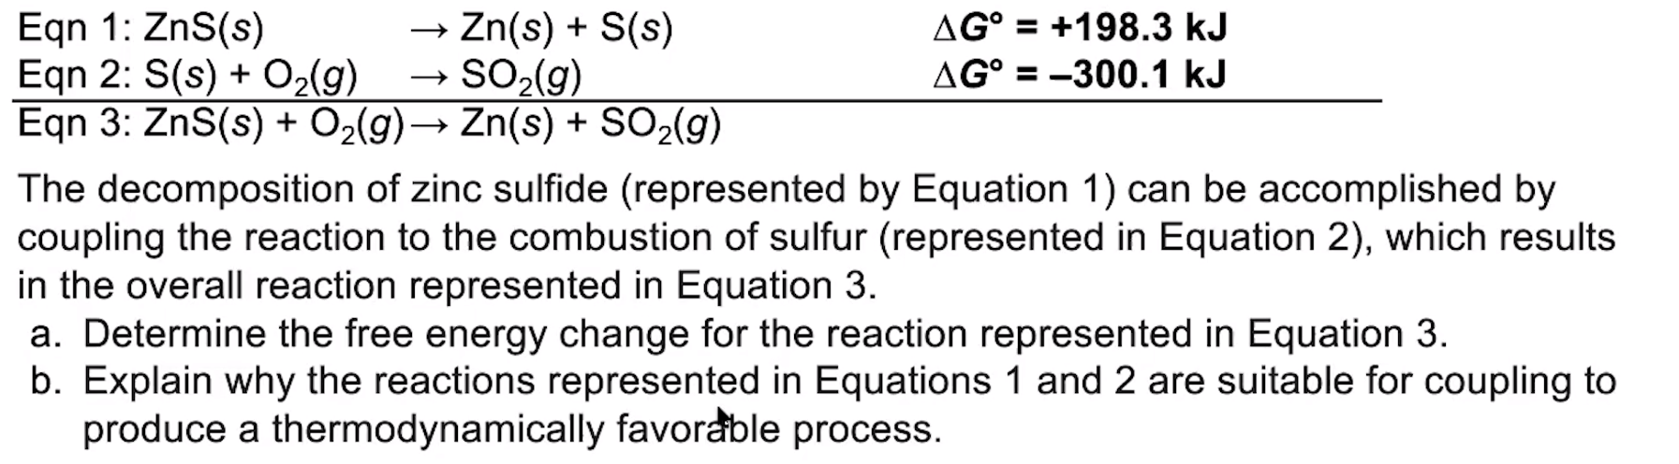

1. **How well did you do on the second problem?**