**AP Chemistry Daily Videos**

**1.2 Mass Spectroscopy of Elements**

[**Video #1**](https://apclassroom.collegeboard.org/7/home?apd=ok5xvp53w8)

1. **Where does the average atomic mass on the periodic table come from?**
2. **Sketch the mass spectroscopy of chlorine as shown in the video. Label key pieces of information on your graph.**
3. **Pause the video at 2:40 and attempt the problem, then evaluate how you did and identify any errors.**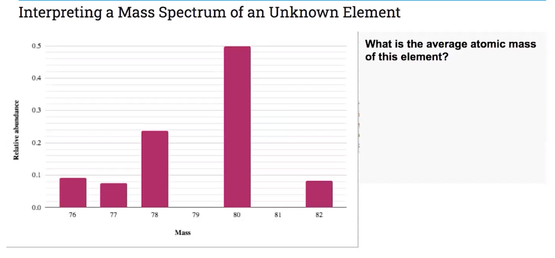

[**Video #2**](https://apclassroom.collegeboard.org/7/home?apd=kej52umthz)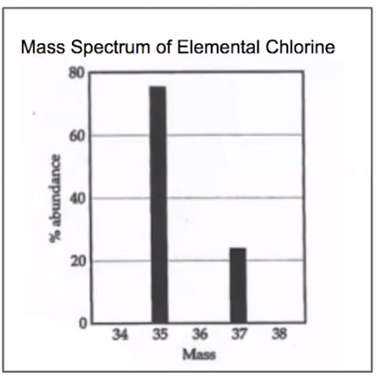

1. **Pause the video at 2:40 and attempt the problem, then evaluate how you did and identify any errors. What is the approximate average atomic mass of Chlorine?**
2. **Pause the video at 2:35 and attempt the problem, then evaluate how you did and identify any errors. Which element’s mass spectrum is shown in the graph?**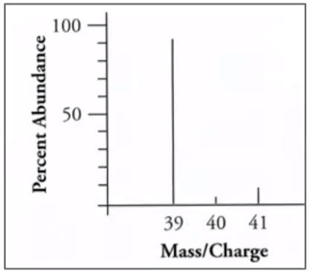
3. **Pause the video at 4:40 and attempt the problem, then evaluate how you did and identify any errors. Identify the element and number of neutrons in the atom represented by the peak at 74 amu in the mass spectrum.**