**AP Chemistry Daily Videos**

**1.4 Composition of Mixtures**

[**Video #1**](https://apclassroom.collegeboard.org/7/home?apd=zhchmwb6cr)

1. How is a mixture different from a pure substance? Be specific and discuss the particle diagrams.
2. Pause the video at 5:16 and attempt the problem, then evaluate how you did and identify any errors.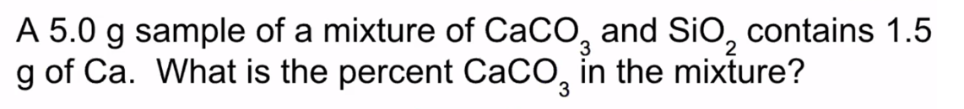

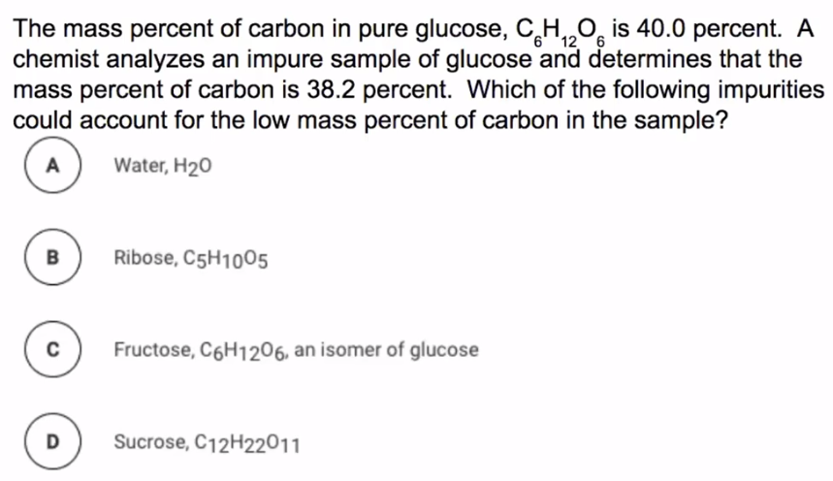

[**Video #2**](https://apclassroom.collegeboard.org/7/home?apd=odavagtpr1)

1. Pause the video at 0:25 and attempt the problem, then evaluate how you did and identify any errors.

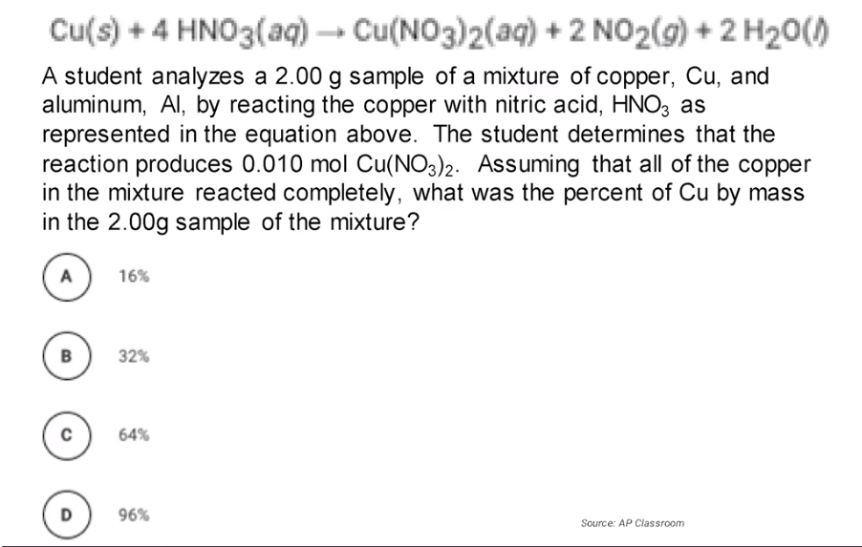

1. Pause the video at 1:51 and attempt the problem, then evaluate how you did and identify any errors.
2. Pause the video at 4:17 and attempt the problem, then evaluate how you did and identify any errors.