**AP Chemistry Daily Videos**

**1.5 Atomic Structure and Electron Configuration**

[**Video #1**](https://apclassroom.collegeboard.org/7/home?apd=0zgns4mi8h)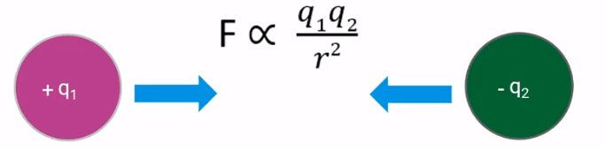

1. Explain the important components of Coulomb’s Law.
2. When distance increases, the force of attraction between two oppositely charged particles _______________. Note that distance is on the denominator of the fraction. When the charge of a particle increases, the force of attraction between two oppositely charged particles ______________. Note that charge is on the numerator of the fraction.
3. Use Coulomb’s law to explain why a valence electron has lower ionization energy than core electrons. 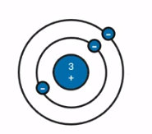

1. Explain why Na’s second ionization energy is so much greater than its first ionization energy. Make sure you focus your answer on Coulomb’s Law.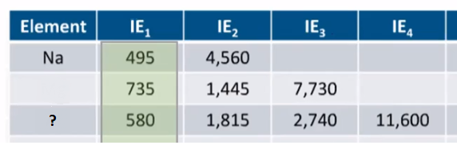
2. Using Coulomb’s Law, why is the second ionization energy always greater than the first, even if the electrons are in the same energy level.
3. Determine what group/family the third element is from. Explain how you know.