**AP Chemistry Daily Videos**

**1.7 Periodic Trends**

[**Video #1**](https://apclassroom.collegeboard.org/7/home?apd=5ck6icbxrn)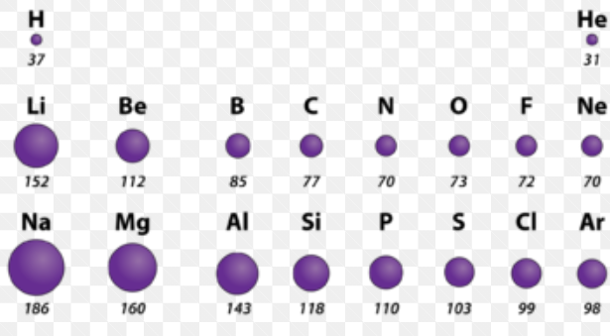

1. Explain the periodic trend of atomic radii using Coulomb’s Law.
2. Explain the periodic trend of IE using Coulomb’s Law, start by defining ionization energy in words or pictures.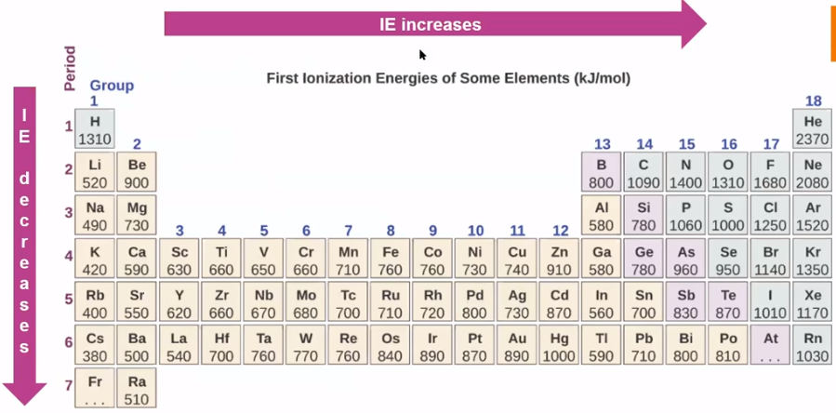
3. Explain the periodic trend of electronegativity using Coulomb’s Law, start by defining it in words or pictures.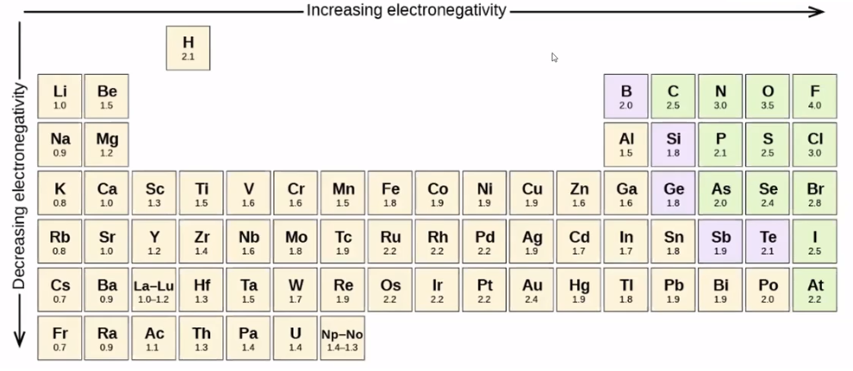
4. Explain the periodic trend of electron affinity using Coulomb’s Law, start by defining it in words or pictures.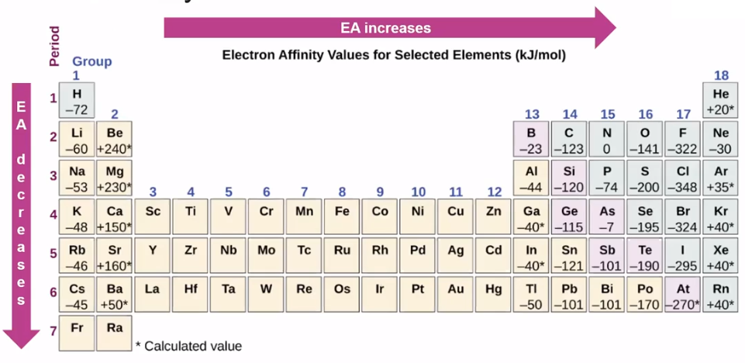

[**Video #2**](https://apclassroom.collegeboard.org/7/home?apd=43xw0twbee)

**1.** Pause the video at 2:10 and attempt the problem, then evaluate how you did and identify any errors. In terms of atomic structure, explain why the atomic radius of gallium is smaller than calcium.

2. Pause the video at 3:47 and attempt the problem, then evaluate how you did and identify any errors. A student claims that the first ionization energy for F is greater than that of Br. Do you agree? Explain why or why not in terms of atomic structure and Coulomb’s law.