**AP Chemistry Daily Videos**

**2.6 Resonance and Formal Charge**

[**Video #1**](https://apclassroom.collegeboard.org/7/home?apd=5q375eg17v)

1. What do resonance structures show and how do you correctly depict a resonance structure? Make sure you include what the double arrows indict.
2. Give an example of how to draw a hybrid resonance structure. Explain what the dotted line represents.

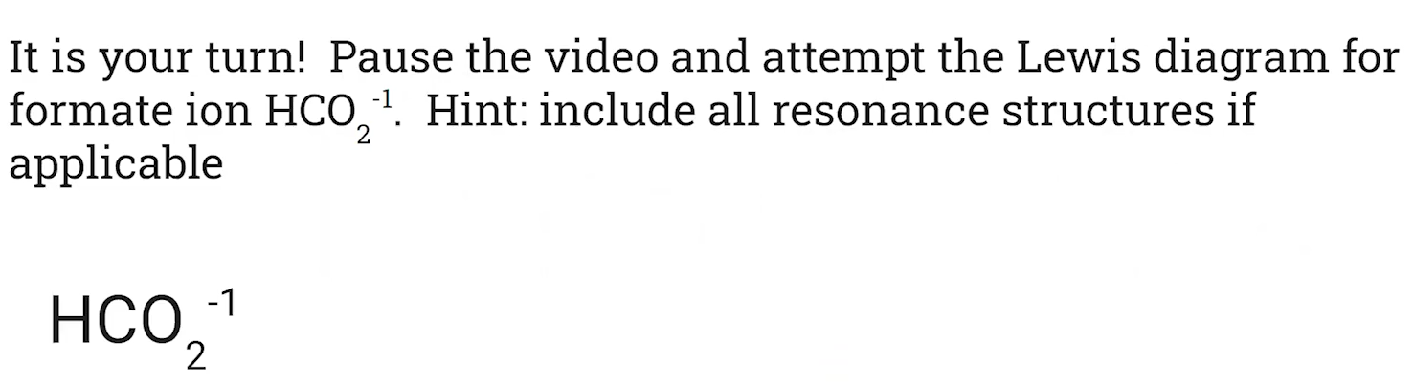

1. Pause the video at 5:07 and attempt the problem, then evaluate how you did and identify any errors.

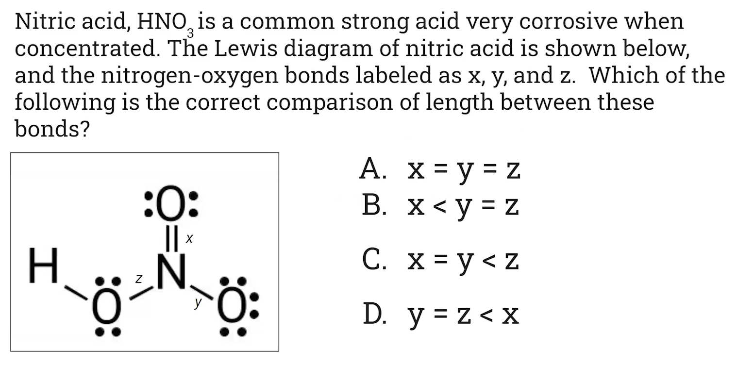

1. Pause the video at 6:30 and attempt the problem, then evaluate how you did and identify any errors.

[**Video #2**](https://apclassroom.collegeboard.org/7/home?apd=mvt88ivwf3)

1. What information do formal charges give us?

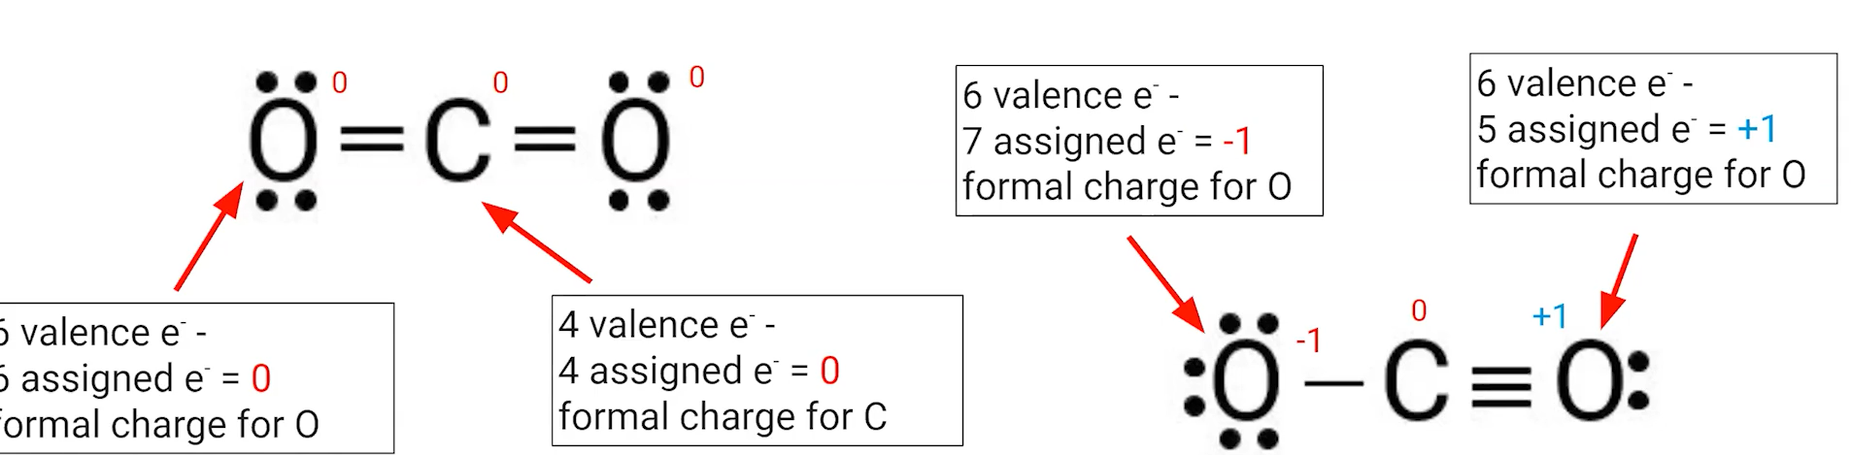

1. How do you assign a formal charge to an atom?
2. How do you use formal charge to determine the best Lewis structure?






1. Pause the video at 6:41 and attempt the problem, then evaluate how you did and identify any errors. 