**AP Chemistry Daily Videos**

**2.7 VSEPR and Bond Hybridization**

[**Video #1**](https://apclassroom.collegeboard.org/7/home?apd=jj3xw6e5lu)

1. What information do Lewis structures leave out?
2. What are electron domains?
3. How does electron repulsions impact shape?
4. Which electron domain impacts the bond angle more than other domains? How does it impact the shape?
5. Write down two important things you learned from using the [Phet simulation for VSEPR](https://phet.colorado.edu/en/simulation/molecule-shapes)?
6. What is the difference between molecular and electron geometry?

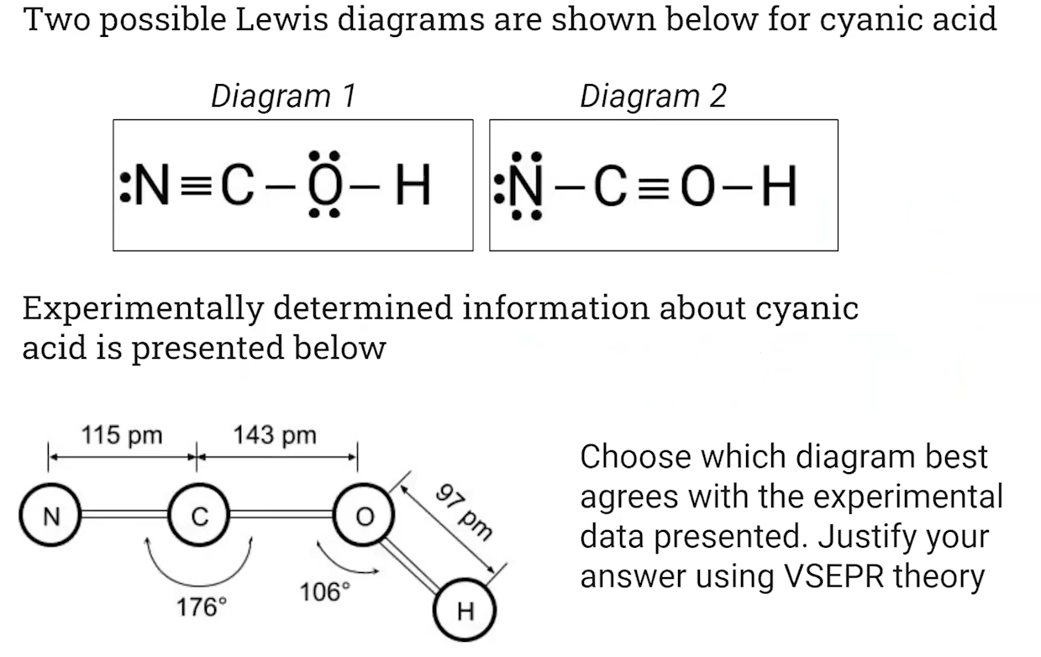

1. Pause the video at 9:35 and attempt the problem, then evaluate how you did and identify any errors.

[**Video #2**](https://apclassroom.collegeboard.org/7/home?apd=occ3p2sgqk)

1. Remind yourself what a dipole moment is.
2. How is it possible that a molecule has a dipole moment BUT the molecule, overall, is not polar? Give an example.
3. How did you do on the “game show” *Polar or nonpolar*?

[**Video #3**](https://apclassroom.collegeboard.org/7/home?apd=fmo6tprqxw)

1. Explain how Carbon, which you know makes four chemical bonds, should only form 2 bonds according to its electron configuration.
2. What are hybrid orbitals?
3. Complete the following table:

| **Hybridized Orbital** | **Energy Diagram** [**Source**](https://chem.libretexts.org/Bookshelves/General_Chemistry/Map%3A_Chemistry_-_The_Central_Science_(Brown_et_al.)/09._Molecular_Geometry_and_Bonding_Theories/9.5%3A_Hybrid_Orbitals) | **Electron Domain Options** | **Molecular Geometry and Angle** |
| --- | --- | --- | --- |
| sp3 | Energy is most similar to 2p.  25% s characteristic and 75% p characteristic. |  |  |
| sp2 | Energy is closer to 2p.  33% s characteristic and 67% p characteristic. |  |  |
| sp | Energy is equidistant between s and p.  50% s characteristic and 50% p characteristic. |  |  |

1. Pause the video at 5:00 and attempt the problem, then evaluate how you did and identify any errors.