AP Chemistry Daily Videos
3.8 Representations of Solutions
Video #1
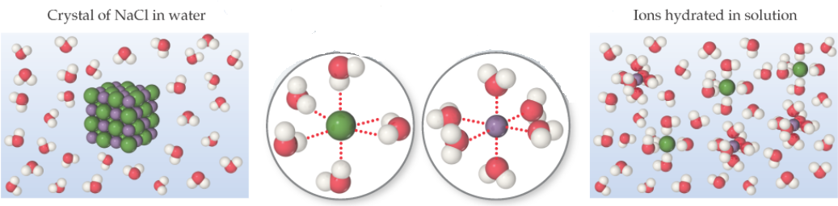
- Study the image above. Based on size, identify the green and purple atoms. Explain your reasoning.

- In the image above, identify the type of IMF shown in the center images.Draw any dipoles, if any.

- Based on the orientation of the water molecules, identify the green and purple atoms. Explain your reasoning. Does your conclusion match your answer in #1?



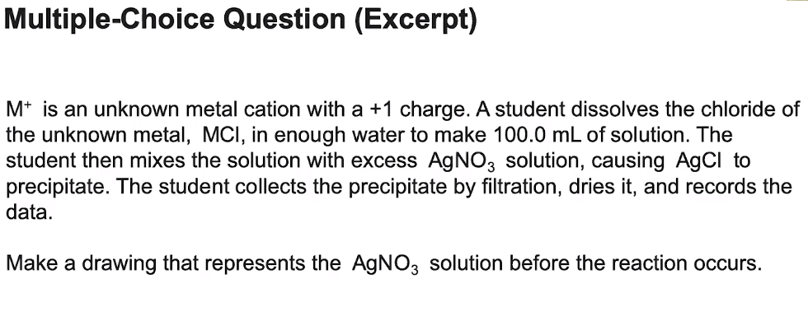
- Pause the video and answer the question to the right.

- Evaluate your response to the answer discussed in the video. How did you do?


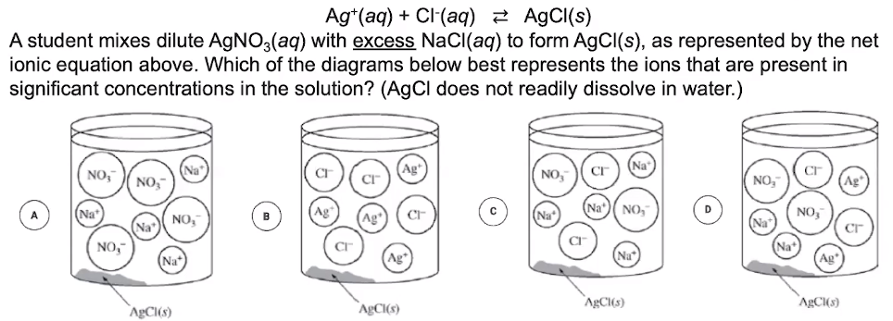
- Answer the MC question above with an explanation for your choice.

- Evaluate your response based on the video’s explanation. What did you overlook if anything?


- Include your drawing for the LiCl problem below.

- According to the scoring guidelines presented, what would you score yourself? How can you improve your score?

- What advice did the teacher give to you about completing particulate diagrams?

