**AP Chemistry Daily Videos**

**4.2 Net Ionic Equations**

[**Daily Video #1**](https://apclassroom.collegeboard.org/7/home?apd=nn0os45n56&unit=4)

1. Give an example of a balanced equation for the melting of ice
2. How does a balance equation demonstrate the law of conservation of mass?
3. Write the balanced equation for the formation of water.
4. Pause the video at 4:00 and attempt the problem, then evaluate how you did and identify any errors.

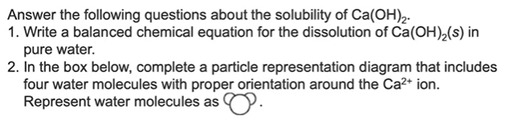

|  |
| --- |

1. What are the takeaways?

[**Daily Video #2**](https://apclassroom.collegeboard.org/7/home?apd=ucrg8ty5r0&unit=4)

1. What are the features of balanced molecular equations, complete ionic equations, and net ionic equations?
2. Pause the video at 4:00 and attempt the problem, then evaluate how you did and identify any errors.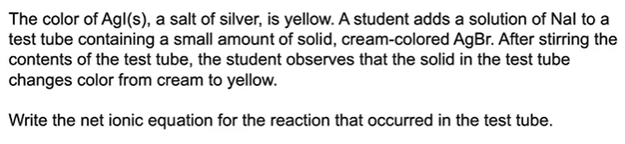
3. Pause the video at 5:28 and attempt the problem, then evaluate how you did and identify any errors.

