**AP Chemistry Daily Videos**

**4.4 Physical and Chemical Changes**

[**Daily Video #1**](https://apclassroom.collegeboard.org/7/home?apd=88ho3mxem9&unit=4)

1. What are the characteristics of a physical process?
2. What is a chemical reaction?
3. Can chemical bonds be broken in a physical change? Give an example.
4. Pause the video at 4:48 and attempt the problem, then evaluate how you did and identify any errors.

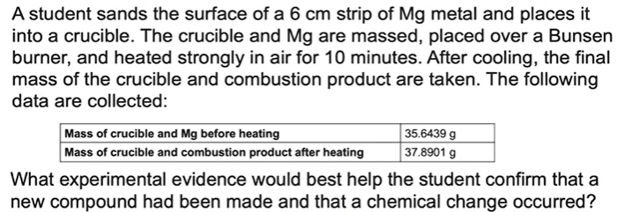

1. What are the takeaways?