**AP Chemistry Daily Videos**

[**4.6 Introduction to Titrations**](https://apclassroom.collegeboard.org/7/home)

[**Video #1**](https://apclassroom.collegeboard.org/7/home?apd=6yzcps848i)

1. **Draw and label the titration setup. Provide a definition for any terms you aren’t familiar with.**
2. **What is the purpose of doing a titration?**
3. **What is the difference between the endpoint and the equivalence point.**

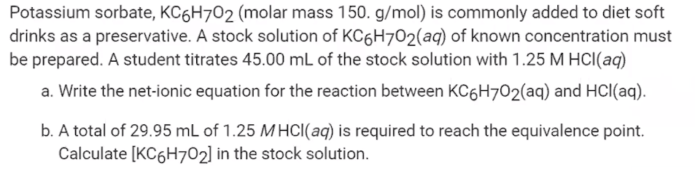

1. **Try the following problems before the teacher completes it. How did you do and what errors did you make?**
2. **Try the following problems before the teacher completes it. How did you do and what errors did you make?**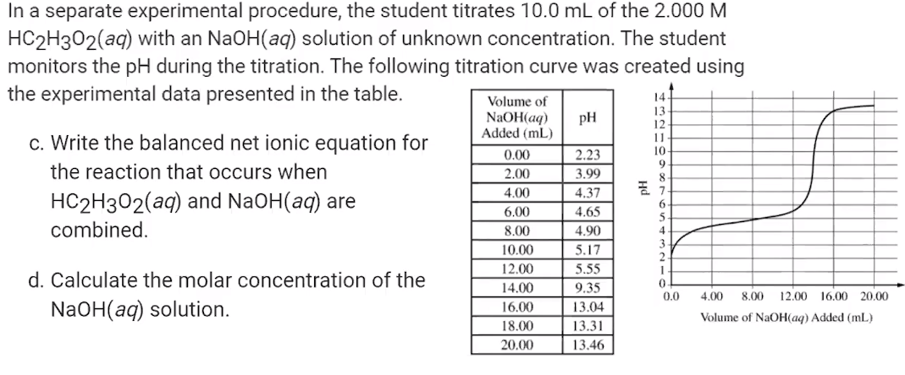

[**Video #2**](https://apclassroom.collegeboard.org/7/home?apd=fdx2a5hxxo)

**1. Besides acid/base reactions. What other reactions can you do titrations on?**

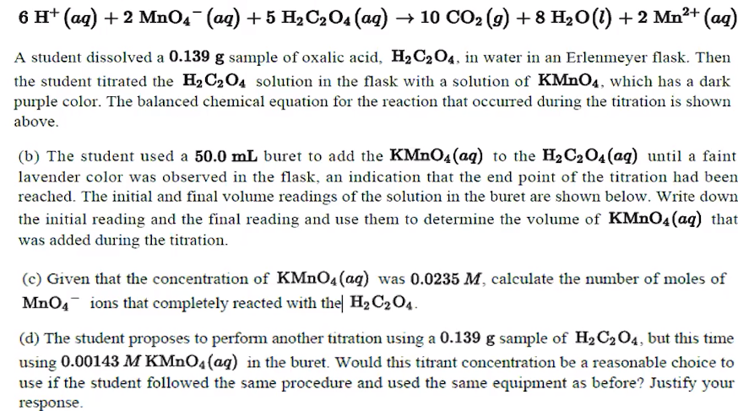

**2. Review this problem with the instructor and write down any errors you make.**

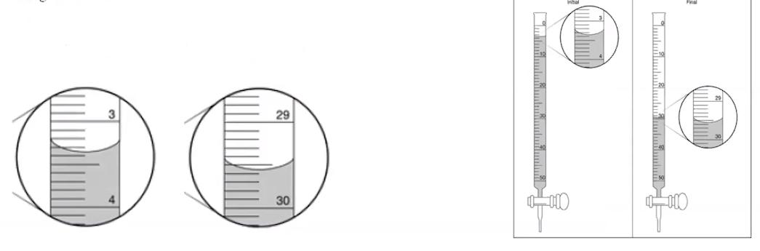

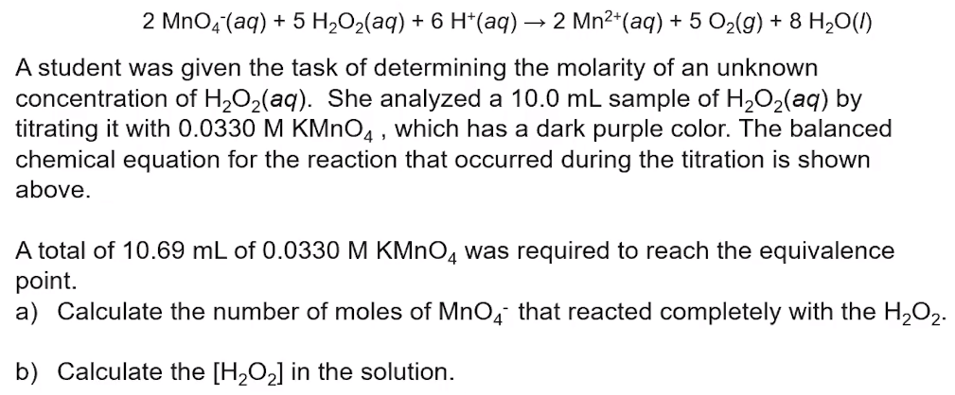

**3. Try the following problems before the teacher completes it. How did you do and what errors did you make?**