**AP Chemistry Daily Videos**

**4.8 Introduction to Acid-Base Reactions**

[**Daily Video #1**](https://apclassroom.collegeboard.org/7/home?apd=g18aq2m97f&unit=4)

1. How do we define a Bronsted-Lowry acid base reaction?
2. What is a Bronsted-Lowry acid? What is a Bronsted-Lowry base?
3. How can you identify a conjugate acid/base pair?
4. What makes water special (amphiprotic)
5. Pause the video at 3:45 and attempt the problem, then evaluate how you did and identify any errors.

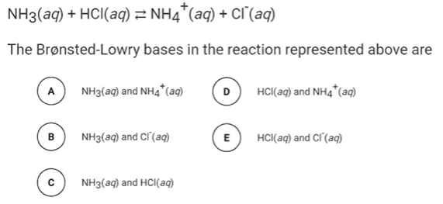

1. Pause the video at 4:58 and attempt the problem, then evaluate how you did and identify any errors.

