**AP Chemistry Daily Videos**

**4.9 Oxidation-Reduction (Redox) Reactions**

[**Daily Video #1**](https://apclassroom.collegeboard.org/7/home?apd=5gdx2pj2zo&unit=4)

1. What are the characteristics of Redox Reactions?
2. Work along with the following example problem.

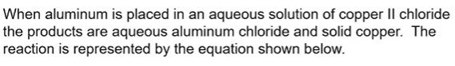

1. Work along with the following example problem.

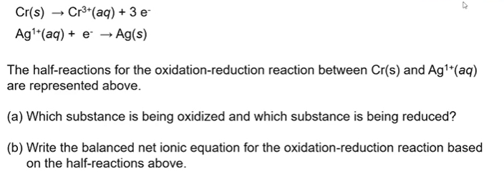

1. Pause the video at 4:05 and attempt the problem, then evaluate how you did and identify any errors.

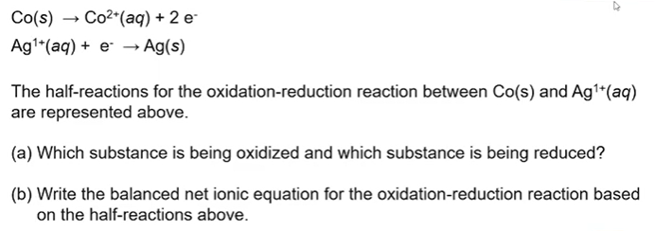

1. Pause the video at 5:12 and attempt the problem, then evaluate how you did and identify any errors.

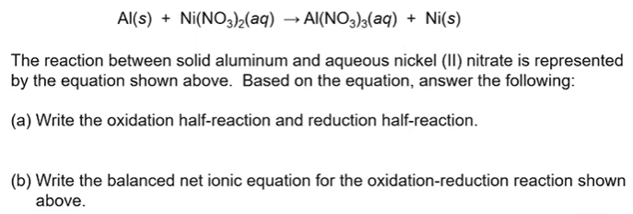

1. What are the takeaways?