**AP Chemistry Daily Videos**

**5.2 Introduction to Rate Law**

[**Video #1**](https://apclassroom.collegeboard.org/7/home?apd=0pphm852p8&unit=5)

1. What is a rate law and how is it determined?
2. The exponent in a rate law is also known as the _______ of the reaction. The sum of the powers of the reactant concentrations in the rate law is the ____________ of the reaction.
3. Identify the rate law, order of reactions, rate constant, and overall rate order from this generic equation. Which variable changes with temperature?

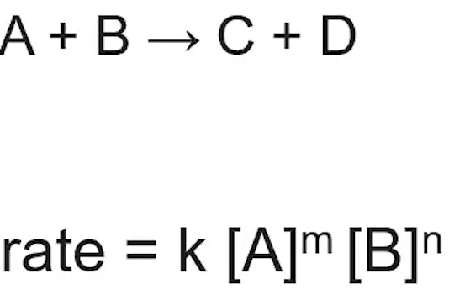

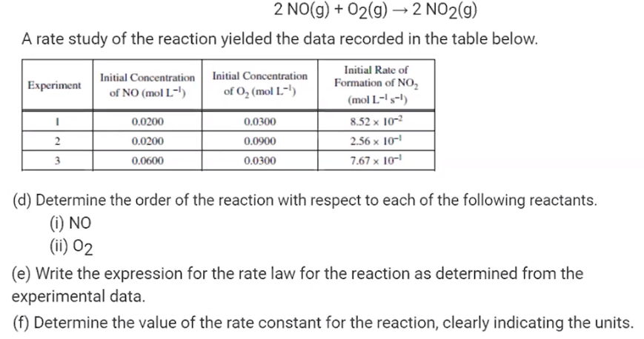

1. Pause the video at 3:11 and attempt the problem, then evaluate how you did and identify any errors.
2. Pause the video at 6:27 and attempt the problem, then evaluate how you did and identify any errors.