**AP Chemistry Daily Videos**

**5.6 Reaction Energy Profile**

[**Video #1**](https://apclassroom.collegeboard.org/7/home?apd=blrz894eoe&unit=5)

1. Describe what information you can gather in a reaction energy profile. Include a sketch of an example, making sure you label key components.
2. What three things must occur in order for a reaction to occur?
3. Put in your own words what activation energy means. Energy needed to do what?
4. Identify the following reactions as exothermic or endothermic. Explain your rationale. In addition, label the activation energy and the ΔH°. Calculate the change in energy.

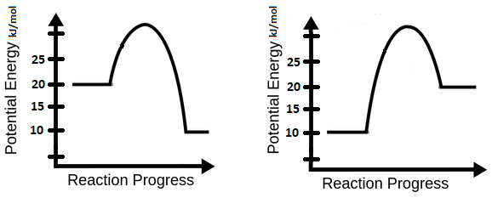

1. What is the activated complex/transition state?
2. If the activation energy increases, and the reactants must collide with even more force, then how does that increase affect the reaction rate?
3. In a different color, label the activation energy of a reverse reaction in the diagrams in #4.

[**Video #2**](https://apclassroom.collegeboard.org/7/home?apd=y7f16j0zlo&unit=5)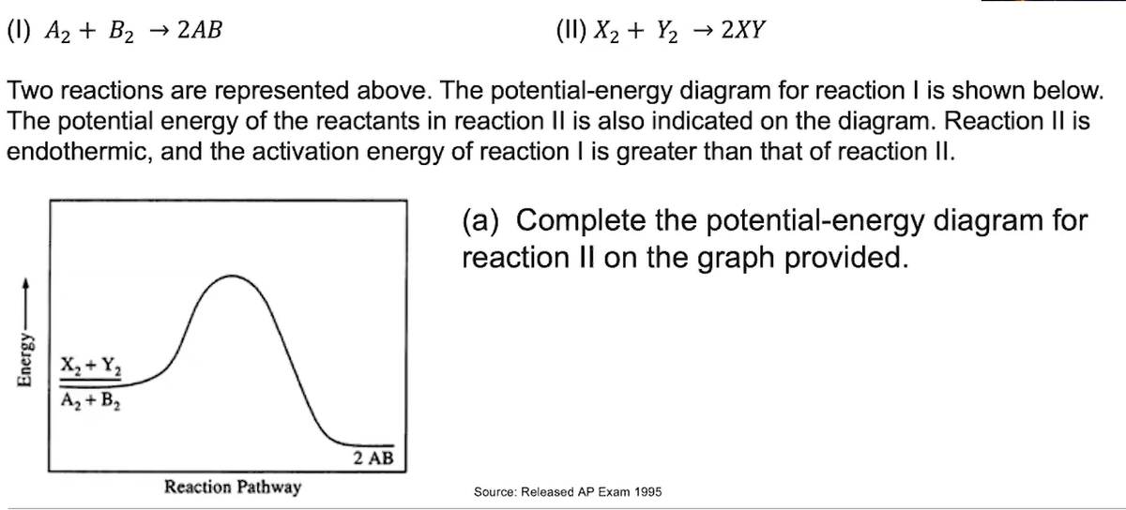

1. Pause the video at 1:30 and attempt the problem, then evaluate how you did and identify any errors. 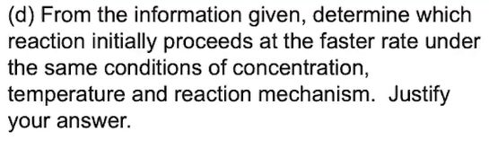

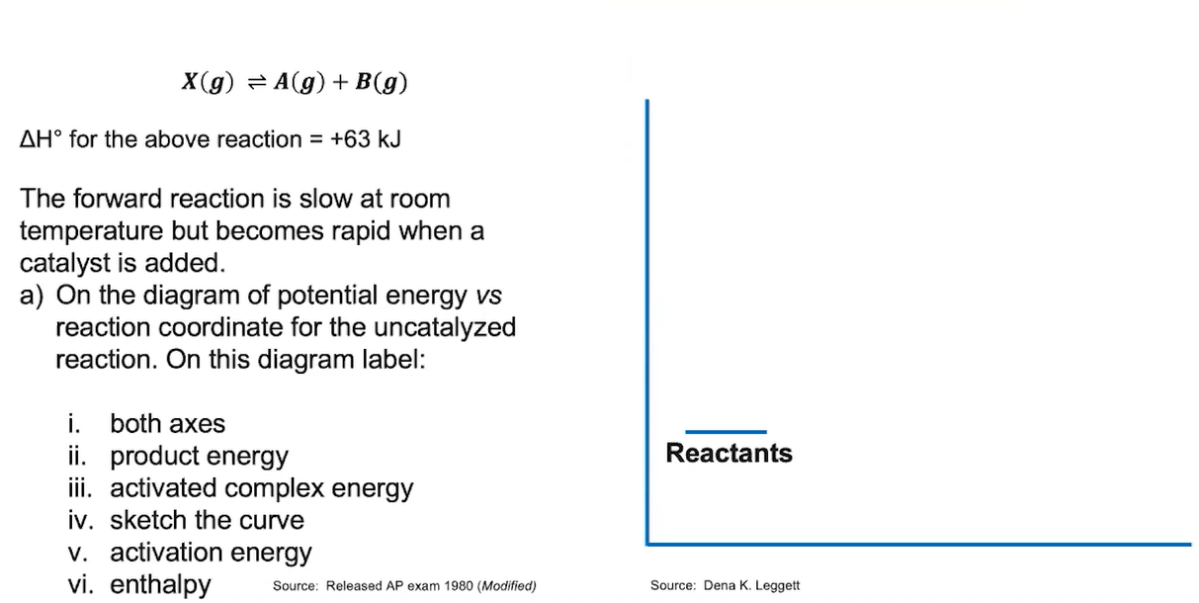

1. Pause the video at 5:30 and attempt the problem, then evaluate how you did and identify any errors.

[**Video #3**](https://apclassroom.collegeboard.org/7/home?apd=1eteodwr8h&unit=5)

1. Complete the table below:

| **Factor that affect reaction rate** | **Why does it affect the rate?** | **Impact on rate constant** |
| --- | --- | --- |
|  |  |  |
|  |  |  |
|  |  |  |
|  |  |  |
|  |  |  |

1. The factors listed above are represented by what variable in the rate law? Use the PhET Simulation [Reactions & Rates](https://phet.colorado.edu/sims/cheerpj/reactions-and-rates/latest/reactions-and-rates.html?simulation=reactions-and-rates) and discuss what you learned.
2. Draw and label the Maxwell-Boltzmann Distribution to show how the number of molecules at or above the activation energy changes with respect to temperature. Shade the area under the curve that represents the number of molecules with enough activation energy and the coldest temperature compared to the hottest temperature. Describe in words what happens as the temperature increases. Does the activation energy change?
3. Redraw the Maxwell-Boltzman graph when a catalyst is used. How does the area under the curve change? Did the activation energy change when the catalyst was used?