**AP Chemistry Daily Videos**

**5.8 Reaction Mechanism and Rate Law**

[**Video #1**](https://apclassroom.collegeboard.org/7/home?apd=qzqqw07lra)

1. Making a rate law from a reaction mechanism is different than when you used data to derive the rate law for an overall reaction. In a reaction mechanism, the rate law is derived from the _______________________ of the balanced equation.
2. Give an example of unimolecular, bimolecular, and termolecular. Which type of reaction is most likely to occur and why?

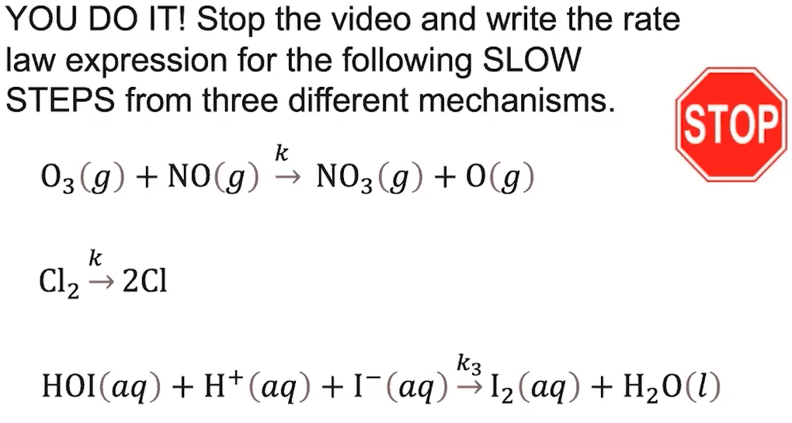

1. Pause the video at 5:08 and attempt the problem, then evaluate how you did and identify any errors. Identify each as unimolecular, bimolecular, or termolecular.

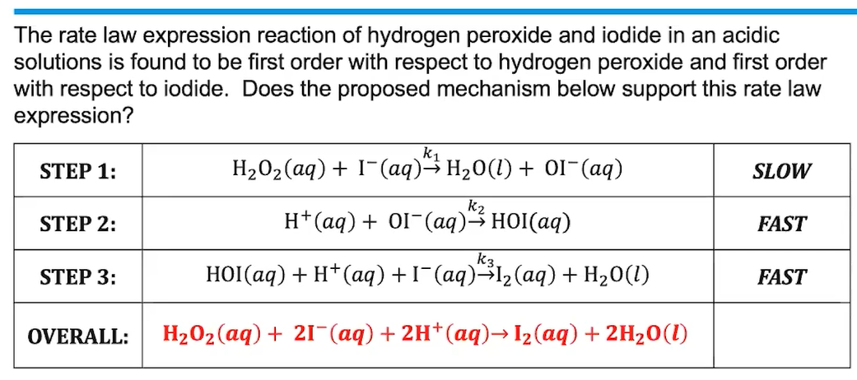

1. Pause the video at 7:00 and attempt the problem, then evaluate how you did and identify any errors.
2. The rate law is always written from the slow or fast step? Why?