**AP Chemistry Daily Videos**

**5.9 Steady-Steady Approximation**

[**Video #1**](https://apclassroom.collegeboard.org/7/home?apd=3cykyaobyn)

1. What do you do if an intermediate shows up in the rate law?
2. What are reversible reactions and what symbol is used to represent it?
3. What is equal in a reaction that has reached equilibrium?

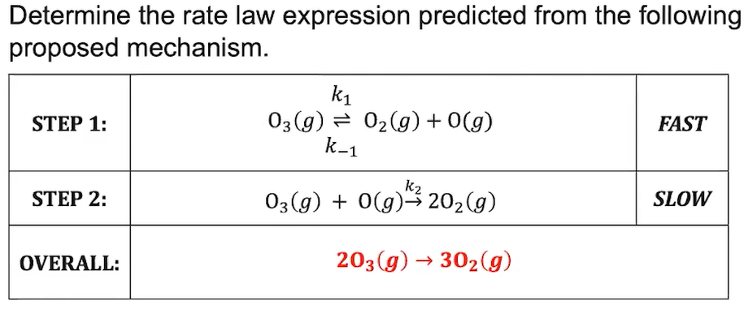

1. Pause the video at 4:40 and attempt the problem, then evaluate how you did and identify any errors.

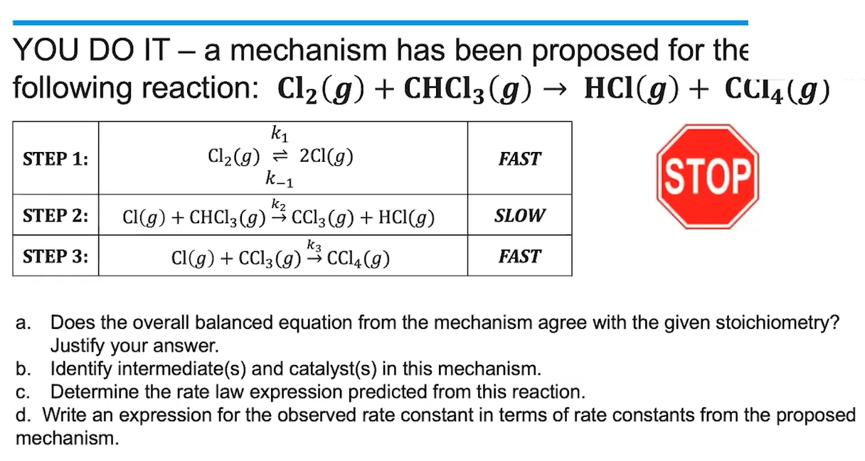

[**Video #2**](https://apclassroom.collegeboard.org/7/home?apd=y0ljw1rqr1)

1. Pause the video at 1:15 and attempt the problem, then evaluate how you did and identify any errors.