**AP Chemistry Daily Videos**

**6.1 Endothermic and Exothermic Processes**

[**Daily Video #1**](https://apclassroom.collegeboard.org/7/home?apd=9lcyae849r&unit=6)

1. When you are breaking a bond or attractive force, what happens to energy?   
   (what is the sign?)
2. When you are forming a bond or attractive force, what happens to energy?   
   (what is the sign?)
3. In a constant pressure system, the net change is called ______________.
4. What is it called when energy to BREAK > energy to FORM? ____________
5. What is it called when energy to BREAK < energy to FORM? ____________
6. What are the takeaways?

[**Daily Video #2**](https://apclassroom.collegeboard.org/7/home?apd=gh67rsrkzb&unit=6)

1. If energy cannot be created nor destroyed, when energy is released by the system, where does it go? (if energy is required by a system, where does it come from?)
2. Describe the flow of heat and the work done in an exothermic process?
3. Describe the flow of heat and the work done in an endothermic process?
4. ** When we measure temperature changes during a chemical reaction we are measuring the ___________!
5. If we measure an INCREASE in temperature the system _________ heat and the reaction is ____________. If we measure a DECREASE in temperature, the system _________ heat and the reaction is _______________.
6. IMPORTANT POINTS:

[**Daily Video #3**](https://apclassroom.collegeboard.org/7/home?apd=z2u6fsfwe3&unit=6)

1. Pause the video at 1:00 attempt the problem, then evaluate how you did and identify any errors.

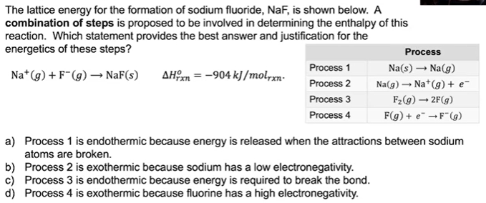

1. Pause the video at 3:57 attempt the problem, then evaluate how you did and identify any errors.

