**AP Chemistry Daily Videos**

**6.2 Energy Diagrams**

[**Daily Video #1**](https://apclassroom.collegeboard.org/7/home?apd=gerg9bcunk&unit=6)

1. Sketch and label a sample energy profile for an exothermic process.
2. Sketch and label a sample energy profile for an endothermic process.
3. Pause the video at 3:42, attempt the problem, then evaluate how you did and identify any errors.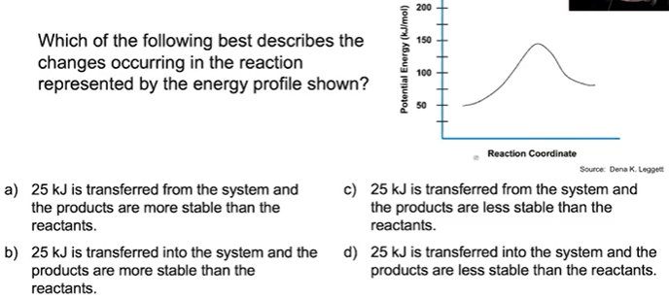
4. Pause the video at 5:30, attempt the problem, then evaluate how you did and identify any errors.

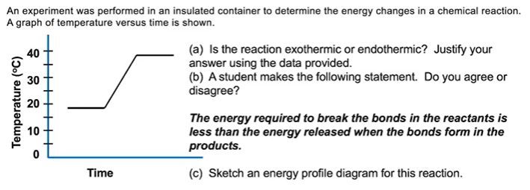

1. What are the takeaways?