**AP Chemistry Daily Videos**

**6.3 Heat Transfer and Thermal Equilibrium**

[**Daily Video #1**](https://apclassroom.collegeboard.org/d/4n8l42oorx?sui=7,6)

Remember: Temperature is a measure of the average kinetic energy of the particles in the sample.

1. What happens to the particles when a hotter object comes into contact with a colder object?
2. What is thermal equilibrium?
3. Pause the video at 4:20, attempt the problem, then evaluate how you did and identify any errors.

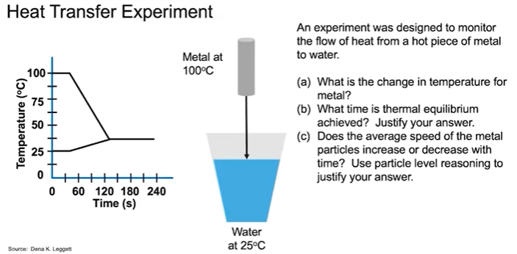

1. What are the takeaways?