**AP Chemistry Daily Videos: 6.4 Heat Capacity and Calorimetry**

**[Video #1](https://apclassroom.collegeboard.org/7/home?apd=bh5i9t9ahk)**

1. **What is Heat Capacity? Discuss a general description and a description with units.**
2. **What the difference between specific heat and molar heat capacity? What do you need to be careful with and watch for during this unit?**
3. **What happens if the heat capacity increases?**
4. **Pause the video at 2:30 to read and attempt the problem, then evaluate how you did and identify any errors.**

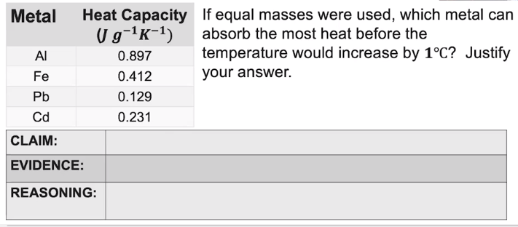

1. **What is the heat transfer equation we will use during our calculations? (Include the units for each piece in the equation.)**
2. **How do we compare heat lost to heat gained. What does the difference in signs tell us? How does this relate to the First Law of Thermodynamics?**
3. **When we look at the heat transfer equation for the salt dissolving in water, what is the mass made up of? Explain.**

**AP Chemistry Daily Videos: 6.4 Heat Capacity and Calorimetry**

**[Video #2](https://apclassroom.collegeboard.org/7/home?apd=ndp3x5g62v)**

1. 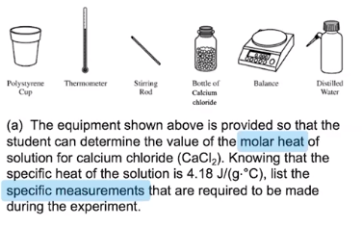**Pause the video at 0:52 to read and attempt the problem, then evaluate how you did and identify any errors. (You only need to list the specific measurements required, but I would also recommend listing necessary equations you may need!)**
2. **Pause the video at 2:35 to read and attempt the problem, then evaluate how you did and identify any errors**.

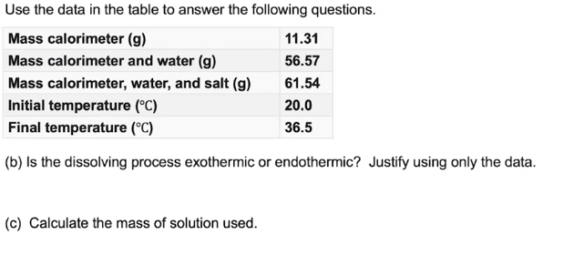

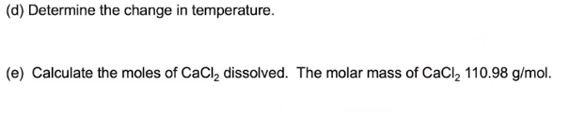



1. **Pause the video at 4:57 to read and attempt the problem, then evaluate how you did and identify any errors**.

