**AP Chemistry Daily Videos: 6.6 Introduction to Enthalpy of Reaction**

**[Video #1](https://apclassroom.collegeboard.org/7/home?apd=1b176vamgf)**

**1. What is the enthalpy change of a reaction showing/telling us?**

**2. At 1:00, you will see two examples what do the signs of ΔH tell us?**

**3. In the second reaction, how much heat is absorbed for 2 moles of NO(g)?**

**4. When can heat be considered a reactant? Product?**

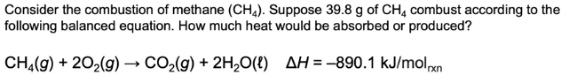**5. Pause the video at 3:13 to read and attempt the problem, then evaluate how you did and identify any errors.**

**6. Pause the video at 4:47 to read and attempt the problem, then evaluate how you did and identify any errors.**

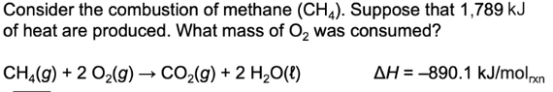

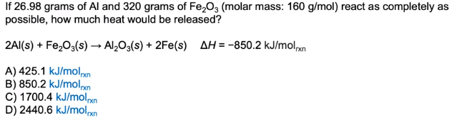**7. Pause the video at 6:03 to read and attempt the problem WITHOUT A CALCULATOR, then evaluate how you did and identify any errors.**