**AP Chemistry Daily Videos**

[**7.1 Introduction to Equilibrium**](https://apclassroom.collegeboard.org/7/home)

[**Video #1**](https://apclassroom.collegeboard.org/d/41qim1ekex?sui=7,7)

1. **What is different about the yield sign in an equilibrium equation?**
2. **What are the 4 examples of reversible reactions provided in the video? What is another example of a reversible reaction that is not mentioned in the video.**

**a)**

**b)**

**c)**

**d)**

**e)**

1. **Draw a picture to represent what equilibrium means to you. Explain how your drawing is an example of equilibrium.**

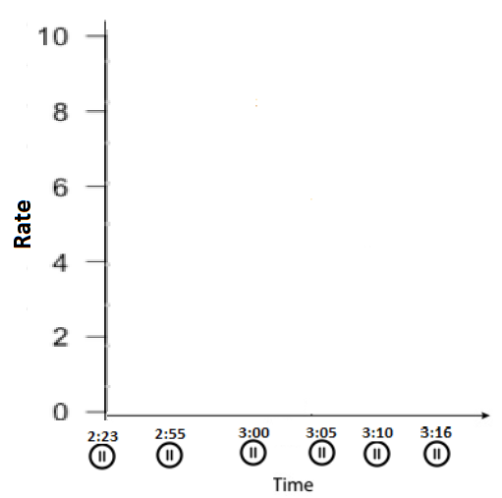

1. **Fill out the graph by drawing two lines to represent the reaction rate of the forward reaction and the reverse reaction. You’ll see where to pause the video on the x-axis to mark the rates for the forward and the reverse directions. Once you are done, connect the dots for each line and label them to indicate the forward and reverse direction.**
2. **Why did the forward direction in your graph decrease over time?**
3. **Why did the reverse direction in your graph increase over time?**



1. **Mark on your graph where equilibrium occurs. What is equal about equilibrium, the concentrations or the Rate? Were the reactants and products at equal concentrations at equilibrium?**
2. **Why is it called *dynamic equilibrium*?**



1. **Summarize the 4 keys points, in your own words, about equilibrium.**