**AP Chemistry Daily Videos**

[**7.10 Reaction Quotient and Le Châtelier’s Principle**](https://apclassroom.collegeboard.org/7/home)

[**Video #1**](https://apclassroom.collegeboard.org/7/home?apd=nqydw703fw)

1. **What is the only stress that leads to a new K?**
2. **Complete the chart using the following terms: reactants, products, forward, and reverse.**

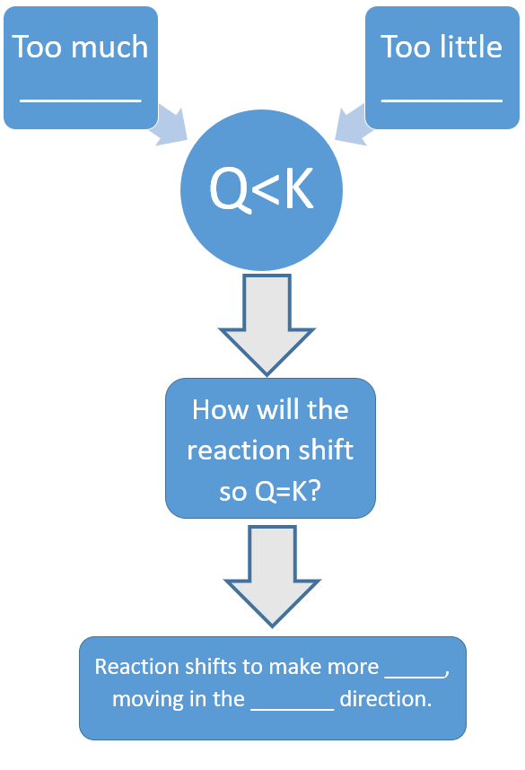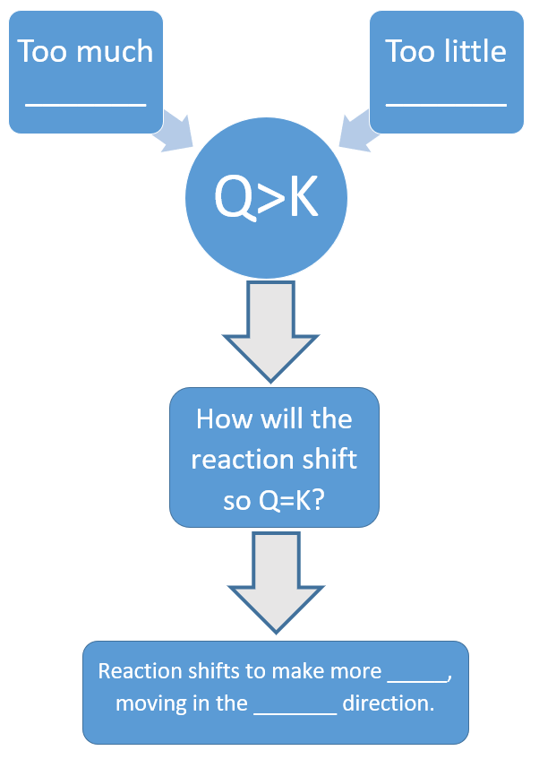



[**Video #2**](https://apclassroom.collegeboard.org/7/home?apd=c7qxmvse3z)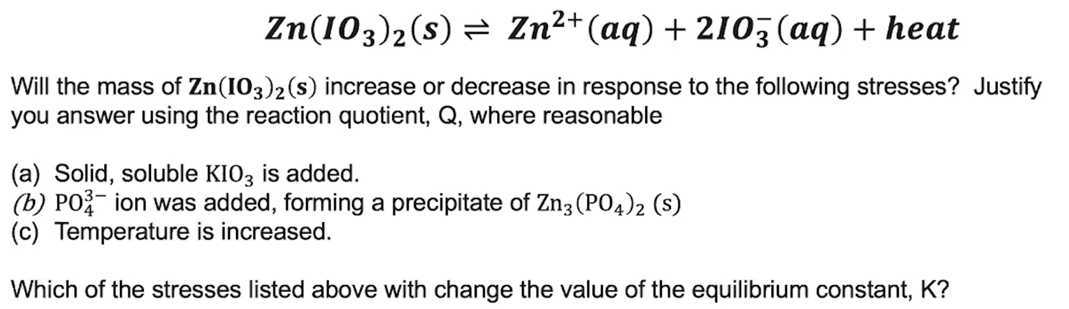

1. **Evaluate how well you did on this problem and identify any errors.**