**AP Chemistry Daily Videos**

[**7.11 Introduction to Solubility Equilibria**](https://apclassroom.collegeboard.org/7/home)

[**Video #1**](https://apclassroom.collegeboard.org/7/home?apd=nem6drc4pp)

1. **Label each diagram as highly soluble or slightly soluble. Also,identify the term for solid particles that form at the bottom of an aqueous solution.**

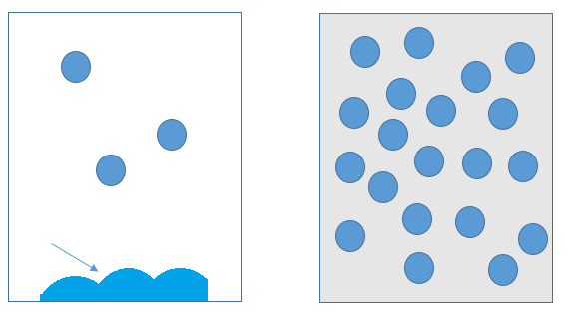

1. **If you have an unsaturated solution, that means more solute can still be dissolved. If you continue to add solute, you will start to see solid collecting at the bottom. This change indicates the solution is now a _______ solution.**
2. **Explain how to write a Ksp equation and what it means. Go back to #1 and identify which diagram has a high Ksp value.**
3. **Ksp describes an equilibrium between what? Use the picture and equation below to help you.**

**NaCl(s) ↔ Na+(aq) + Cl- (aq)**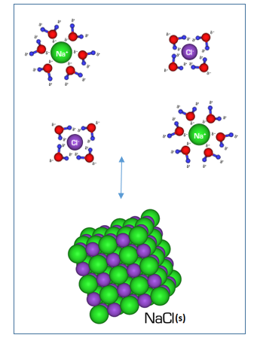

1. **Is it technically accurate to say a substance is insoluble? Why or why not? Provide an example of the Ksp value for a substance that is essentially insoluble.**
2. **What is a common error the instructor warns you about?**



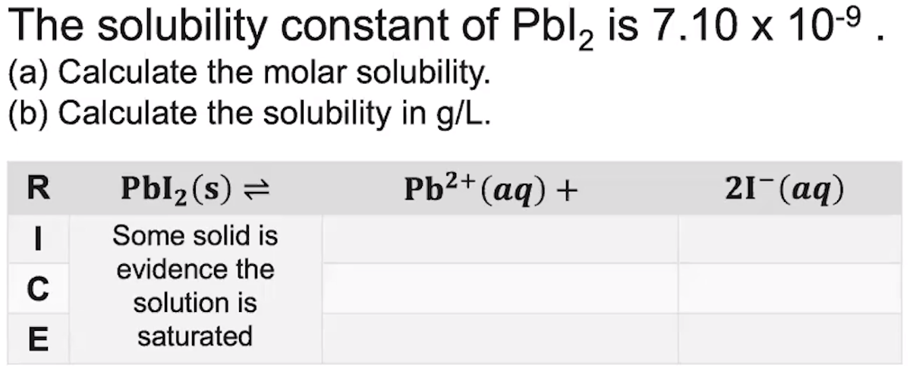

1. **Evaluate how well you did on this problem and identify any errors you may have made.**
2. **Write down the 4 main points at the end of the video.**

**1.**

**2.**

**3.**

**4.**

[**Video #2**](https://apclassroom.collegeboard.org/7/home?apd=dd7ht4wv0y)

1. **What is comparing Ksp values by themselves not a good idea?**



1. **Complete the table:**

| **Qsp<Ksp** | **Qsp>Ksp** |
| --- | --- |
| **There are ________ ions.** | **There are ________ ions.** |
| **Solution is ____________** | **Solution is ____________** |
| **A precipitate __________________** | **A precipitate __________________** |

1. **Take notes on the sample problem the instructor completed. What did you learn?**

[**Video #3**](https://apclassroom.collegeboard.org/7/home?apd=g3qggch9gp)

1. **Take notes on the steps your instructor takes to solve the following problems.**







**\*Note, nitrates and most Group 1 elements are highly soluble, meaning they ionize completely. Notice there’s no equilibrium sign here, only a forward yield sign. Cr(NO3)3(s) → Cr3+(aq) + 3NO3-(aq), the mole ratio is 1:1:3. All of the Cr(NO3)3 becomes products, so Cr3+ is the same concentration as Cr(NO3)3, 1.1x10-8M. KOH(s) → K+(aq) + OH-(aq), 1:1:1, so OH- equals 9.5x10-9M. In short, by telling you the concentrations of the reactants of highly soluble substances, they are giving you enough information to find the concentrations of the ions.**

1. **How did you do?**