**AP Chemistry Daily Videos**

[**7.13 pH and Solubility**](https://apclassroom.collegeboard.org/7/home)

[**Video #1**](https://apclassroom.collegeboard.org/7/home?apd=cw2lf3833j)

1. **What is the generic neutralization reaction?**
2. **What ion should you think about when you are told a solution has been acidified? What ion is associated with a base or alkaline solutions?**
3. **You know that opposite charges _______. When you have a solution with acidic or basic ions in it, meaning the solution has a pH other than 7, watch out, these ions will bond with ions from the salt - essentially reducing their concentration and shifting the reaction.**

**Ex: BaF2(s) ↔ Ba2+(aq) + 2F-(aq) Predict what will happen in an acidic solution?**

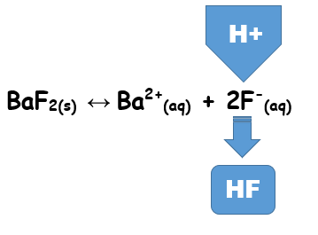

**Check: The concentration of fluoride ion decreases, shifting the reaction in the forward direction, increasing solubility. Fluoride ion decreases because it bonds with H+ ions, forming a weak acid. Evaluate your prediction.**

1. **Ex: AgI(s) ↔ Ag+(aq) + I-(aq) Predict what will happen in an acidic solution?**

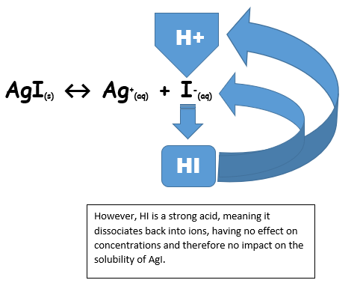

**Check: Evaluate your prediction.**



1. **Evaluate your answer to the following question.**