**AP Chemistry Daily Videos**

[**7.3 Reaction Quotient and Equilibrium Constant**](https://apclassroom.collegeboard.org/7/home)

[**Video #1**](https://apclassroom.collegeboard.org/7/home?apd=y6do4kmv0t)

1. **Identify all the parts in the equation for Q. Describe how these items change for gases.**

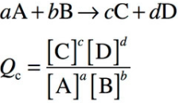

1. **Why are only gases and aqueous included in the reaction quotient formula? Answer in terms of Molarity (mol/L).**



1. **Try following the problem before the explanation and answer is given. If you got it wrong, what was your misunderstanding? Write Q for:**
2. **You learned that the concentrations of reactants and products do not change when a system reaches equilibrium. What equation is used to measure the concentrations at equilibrium?**

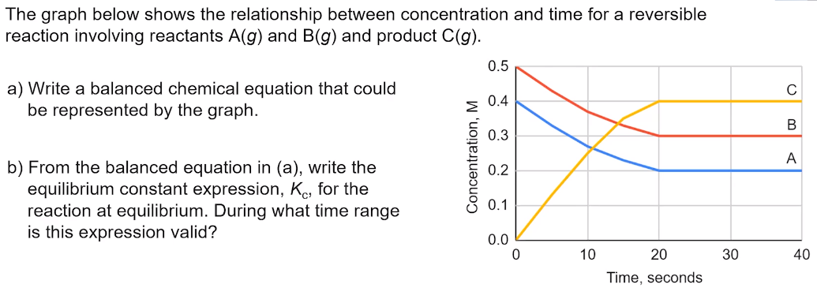

1. **Try following the problem before the explanation and answer is given. If you got it wrong, what was your misunderstanding?**

