**AP Chemistry Daily Videos**

[**7.5 Magnitude of the Equilibrium Constant**](https://apclassroom.collegeboard.org/7/home)

[**Video #1**](https://apclassroom.collegeboard.org/7/home?apd=9ao7u17cze)

| **Visual** | **Question** | **Answer** |
| --- | --- | --- |
|  | **What happens to the value of a fraction as the numerator gets larger?** |  |
|  | **What happens to the value of a fraction as the denominator gets larger?** |  |
|  | **Remember that calculating K, products are in the numerator and reactants are in the denominator. What do you know if K is larger than 1? Draw a picture to the left to represent what happens when K is large.** | **Which side of the equation is favored?** |
|  | **What do you know if K is less than one? Draw a picture to the left to represent what happens when K is small.** | **Which side of the equation is favored?** |
|  | **What do you know if K=1? Draw a picture to the left to represent what happens when K=1.** | **Which side of the equation is favored?** |

1. **Ksp is a specific equilibrium constant called the solubility product constant. What does it represent?**
2. **Label each image as either: Large Ksp or Small Ksp**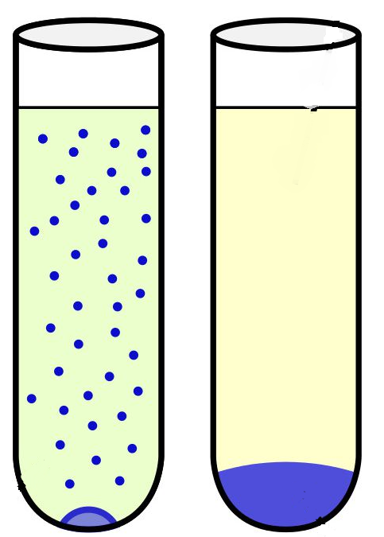



1. **Evaluate how you did in example 1 and identify any errors.**





1. **Try to complete this problem before the answer is given. Evaluate how you did and identify any errors you made.**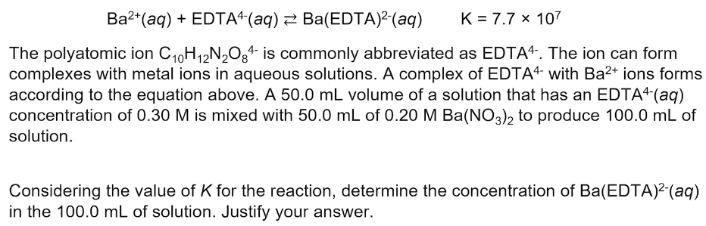
2. **What does it mean when an equilibrium reaction is said to go “essentially to completion”?**
3. **Summarize the four key takeaways.**