**AP Chemistry Daily Videos**

[**7.6 Properties of the Equilibrium Constant**](https://apclassroom.collegeboard.org/7/home)

[**Video #1**](https://apclassroom.collegeboard.org/7/home?apd=930lhi0tno)



1. **Write K value for the forward and reverse direction of the following reaction:**
2. **If K in the above reaction equals 3, what is Krev?**
3. **Write a generic example, not used in the video, of how you’d calculate an overall K from a series of reactions.**
4. **What rule would you state happens to K as the coefficient changes, based on the example:**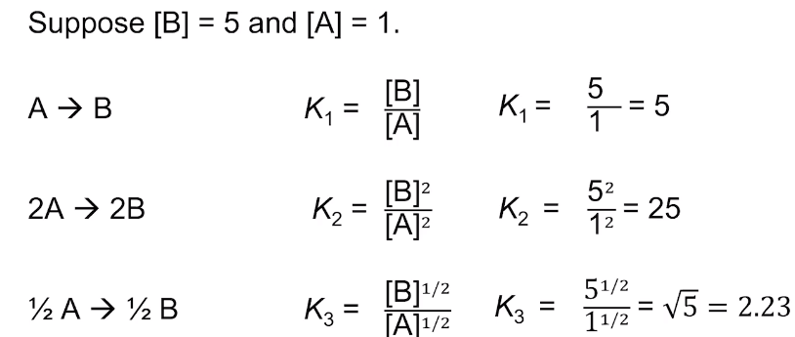
5. **How is Q different than K? Which one is used if you are not at equilibrium?**

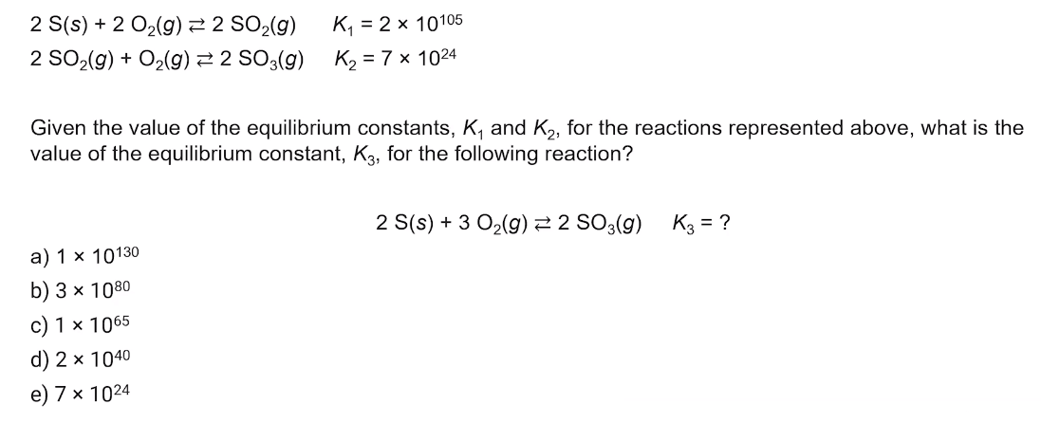

1. **Try to complete this problem before the answer is given. Evaluate how you did and identify any errors you made.**
2. **Try to complete this problem before the answer is given. Evaluate how you did and identify any errors you made.**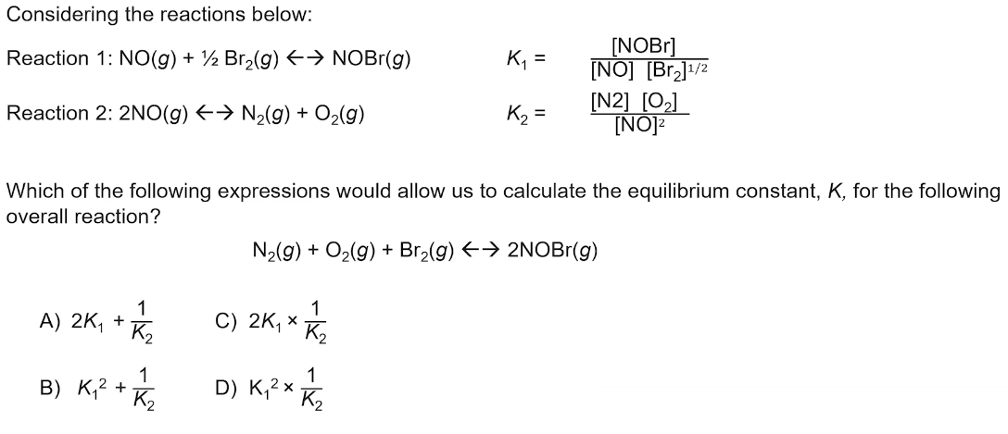
3. **Summarize the 4 key takeaways.**