**AP Chemistry Daily Videos**

[**7.7 Calculating Equilibrium Concentrations**](https://apclassroom.collegeboard.org/7/home)

[**Video #1**](https://apclassroom.collegeboard.org/7/home?apd=8jrk78ksm7)

1. **Recall that K is only used when the system has reached equilibrium. Q is used to evaluate if a reaction is at equilibrium and what changes must occur to reach equilibrium. Complete the following table.**

|  |  |  |  |
| --- | --- | --- | --- |
| **Is this system at equilibrium (Yes or No)?** |  |  |  |
| **How are Q and K related (=,<, >)?** |  |  |  |

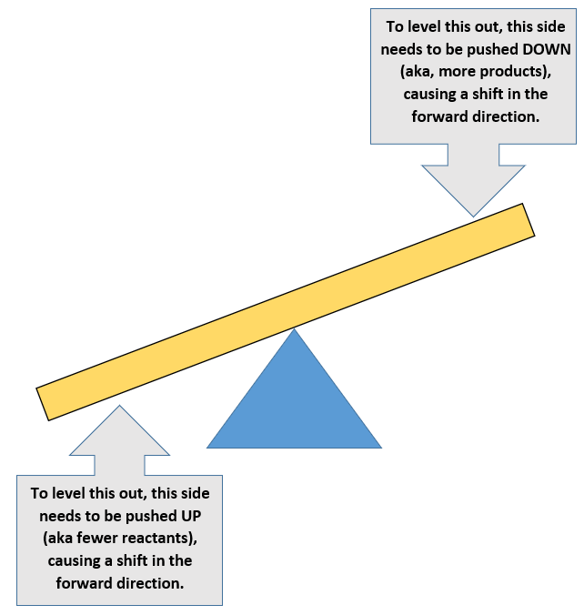

1. **Reactions move towards equilibrium Recall that both Q and K are products/reactants.Complete the following table to indicate how the reaction would shift to reach equilibrium.**

|  |  |  |  |
| --- | --- | --- | --- |
| **Would products need to be increased or decreased** |  |  |  |
| **Would reactants need to be increased or decreased?** |  |  |  |
| **What direction would the reaction shift to reach equilibrium?** |  |  |  |

1. **Evaluate how you did and identify any errors you made.**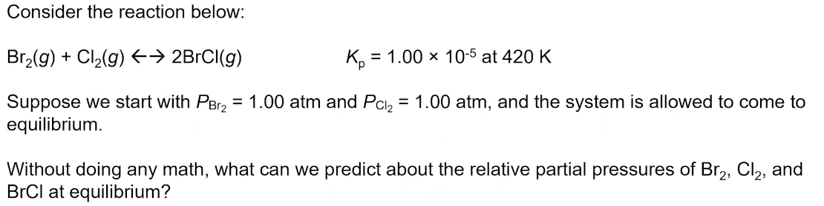
2. **Draw the ICE table and describe what information is placed in each area. What row represents the information associated with Q? For K?**
3. **Highlight the steps in your own words of how she solved the problem.**
4. **When can you assume plus or minus a value of x is so insignificant that you can ignore it?**

[**Video #2**](https://apclassroom.collegeboard.org/7/home?apd=6xbcxhsu4o)

1. **Evaluate how you did in examples 1 and 2 and identify any errors you made.**



1. **Try sample 3 and evaluate any errors you may have made.**