**AP Chemistry Daily Videos**

[**7.8 Representations of Equilibrium**](https://apclassroom.collegeboard.org/7/home)

[**Video #1**](https://apclassroom.collegeboard.org/7/home?apd=n4o2h8pqle)

1. **What assumptions should you make about particle diagrams?**
2. **How should you approach these diagrams?**

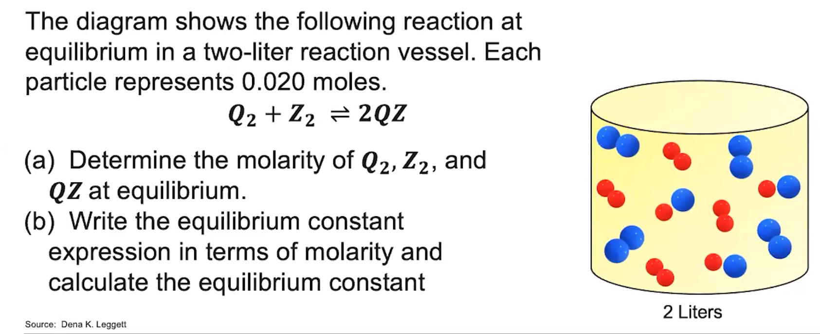

1. **Evaluate how you did and identify any errors you may have made.**