**AP Chemistry Daily Videos**

[**7.9 Introduction to Le Châtelier’s Principle**](https://apclassroom.collegeboard.org/7/home)

[**Video #1**](https://apclassroom.collegeboard.org/7/home?apd=s19mq5w1a1)

1. **Identify 5 ways a system can be stressed and what that does to the reaction.**



1. **How can you tell by the graph that the system was at equilibrium?**
2. **Complete the table by drawing how a system will respond to the following stresses.**

| **Stress** | **Response and Rationale** | **Picture Representation** |
| --- | --- | --- |
| **Reactant is Increased** |  |  |
| **Reactant is Decreased** |  |  |
| **Removing Water (Increasing concentration)** |  |  |
| **Adding Water (Dilution)** |  |  |
| **Adding an Ion** |  |  |

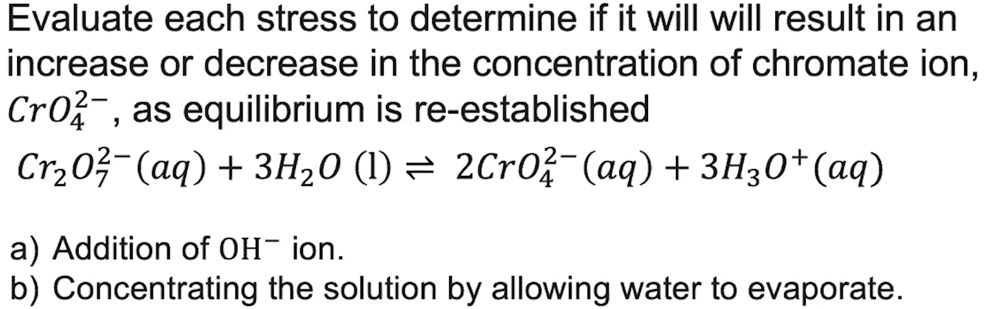

1. **Fill out your response below. Compre your response to the instructor’s and identify any ways you could improve.**

| **Claim** |  |
| --- | --- |
| **Evidence** |  |
| **Reasoning** |  |

[**Video #2**](https://apclassroom.collegeboard.org/7/home?apd=89vmdz9p7i)



| **Stress** | **Response and Rationale** | **Picture Representation** |
| --- | --- | --- |
| **Pressure is increased** |  |  |
| **Pressure is decreased** |  |  |
| **Catalyst is added** |  |  |
| **Adding a solid** |  |  |

1. **When evaluating how pressure changes a reaction with gas molecules, what caution did the instructor provide?**

[**Video #3**](https://apclassroom.collegeboard.org/7/home?apd=1f5y5gf88u)

1. **If a reaction is exothermic in the forward direction, then it is ____________ in the reverse direction.**

| **Stress** | **Response and Rationale** | **Picture Representation** |
| --- | --- | --- |
| **Temperature is added to an endothermic reaction** |  |  |

1. **Explain in words or pictures why K is larger for endothermic reactions that are heated.**

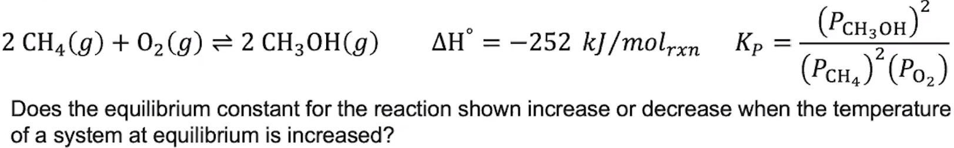

1. **Evaluate your response to the following question. Make sure you explained your choice.** 
2. **How did you do on the last few problems?**