**AP Chemistry Daily Videos**

[**8.1 Introduction to Acids and Bases**](https://apclassroom.collegeboard.org/7/home)

[**Video #1**](https://apclassroom.collegeboard.org/7/home?apd=wfvxyxitz1)

1. **What does Kw represent? At what temperature is it equal to 1x10-4?**
2. **Complete the following table:**

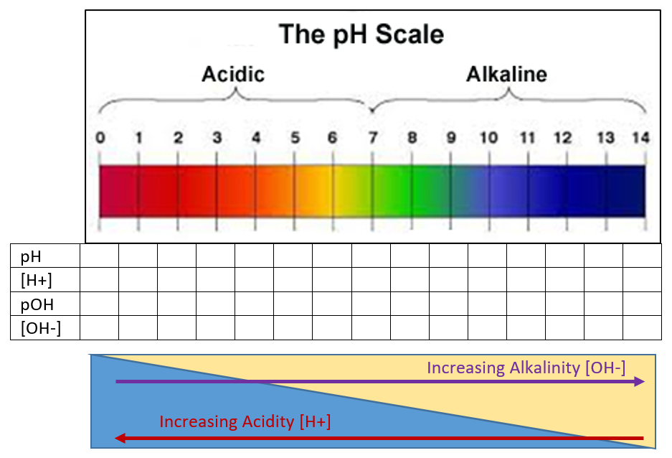

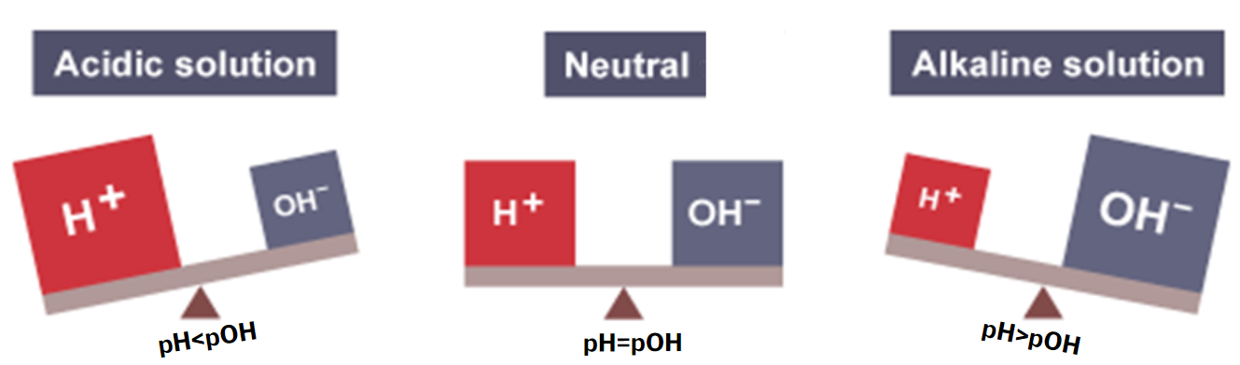

1. **As pH increases acidity ________________________.**
2. **Did your answers match the instructor’s?** 

[**Video #2**](https://apclassroom.collegeboard.org/7/home?apd=bdyuf15ah9)

1. **Estimate the pH if the [H+]= 5x10-8 M**
2. **If Kw increases as temperature increases, more ___________ is formed. Based on this statement, deduce if the dissociation of water is endothermic or exothermic?**
3. **Regardless of temperature, [H+] and [OH-] are always _______ in pure water or neutral solutions. For solutions that aren’t neutral, you can find the concentrations of H+ and OH- by using the formula Kw=[H+][OH-].**
4. **Neutral pH doesn’t always equal 7. Under what condition does water have a neutral pH of 7?**
5. **pH and pOH are always _____ in pure water. However, pH + pOH doesn’t always equal 14. Under what conditions does pH+pOH=14?**
6. **How does pKa values relate to Ka values?**
7. **Complete the table by adding the words strong and weak.**

|  | **_____ Acids ____ Acids** | | | |
| --- | --- | --- | --- | --- |
| **pKa** | **-4** | **-2** | **8** | **14** |
| **Ka** | **1x104** | **1x102** | **1x10-8** | **1x10-14** |

1. **Evaluate your work on the following problem.** 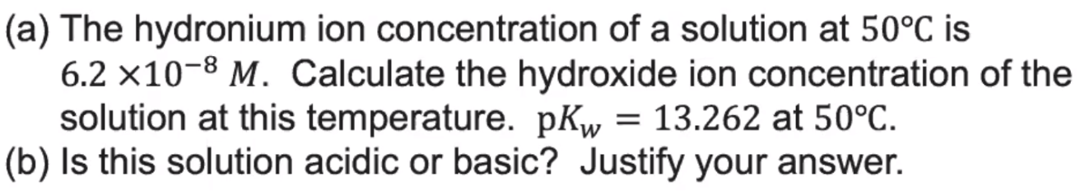
2. **As temperature increases, the pH of pure water ___________.**
3. **What is the best way to determine if a solution is acidic or basic?**
4. **True or False?**

| **Statement** | **True/False? If False, rewrite the statement to make it true.** |
| --- | --- |
| **pH=pOH for all neutral solutions at all temperatures** |  |
| **[H+]=[OH-] for all neutral solutions at all temperatures** |  |
| **Kw = Ka x Kb at all temperatures** |  |
| **pKa + pKb = 14 at all temperatures** |  |
| **Kw=1.0x10-14 at all temperatures** |  |
| **pH+pOH=14 at all temperatures** |  |

**Check: The first three statements are true, the last three are false. They are only true at 25°C.**

1. **Let’s work this problem another way to repeat what was stated above:**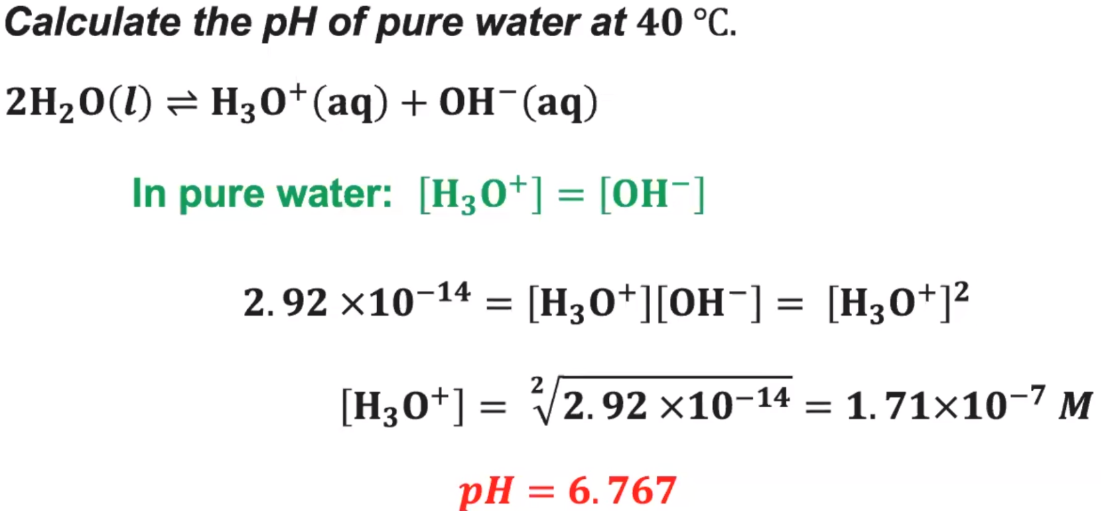

**Because this problem is at 40°C, Kw=2.92x10-14**

**2.92x10-14=[H+][OH-]=[OH-]2**

**[OH-]=1.71x10-7M**

**This makes sense because we see that the concentrations of H+ and OH- are always equal in pure water.**

**Since the concentrations are equal, pH must equal pOH because they are both -log of their ion’s concentration.**

**pOH=6.767**

**Don’t make the mistake of thinking pOH=14-pH, this can only be used at 25°C.**

**You could use pOH=x-6.767, where x=-logKw=-log 2.92x10-14=13.5346.**

**At 40°C, pOH=13.5346-pH = 13.5346-6.767= 6.768**

**pH+pOH=13.5346**