**AP Chemistry Daily Videos**

[**8.10 Buffer Capacity**](https://apclassroom.collegeboard.org/7/home)

[**Video #1**](https://apclassroom.collegeboard.org/7/home?apd=oc275a21kf)

1. **Does diluting a buffer solution change the pH? Why or why not?**
2. **What is buffer capacity and what determines its capacity?**
3. **According to the Henderson-Hasselbalch Equation, what would you need to change in order to change the pH of the buffer solution?**
4. **Evaluate your work.** 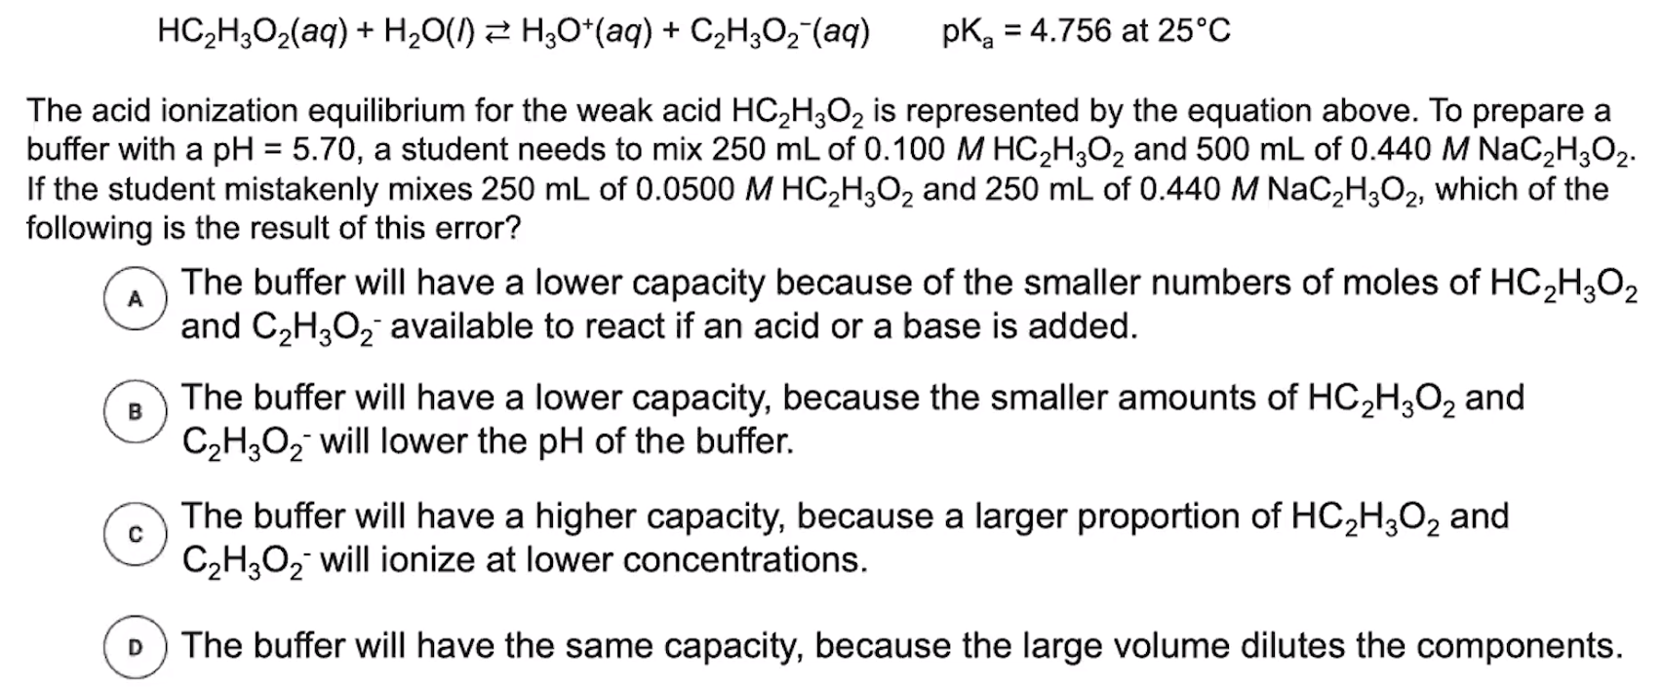

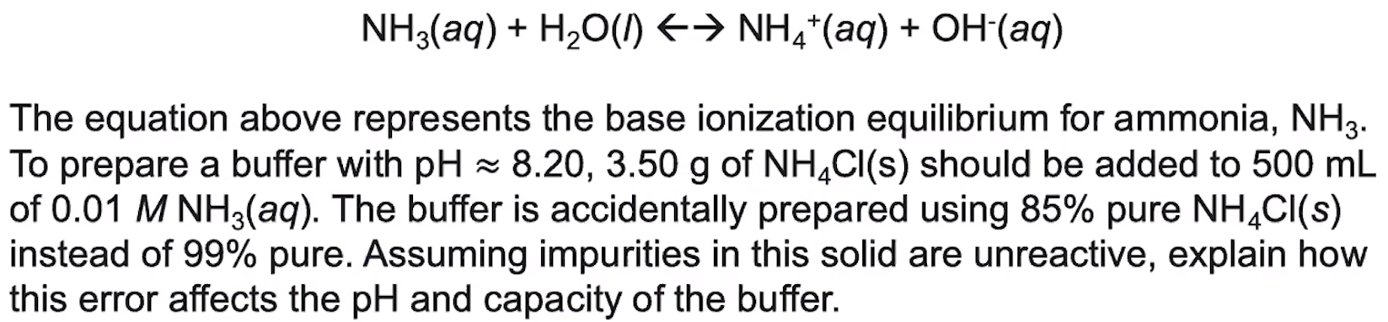

1. **To begin this problem, identify your weak base and its conjugate acid in the reaction.**
2. **Write down the three key points from this video in your own words.**