**AP Chemistry Daily Videos**

[**8.2 pH and pOH of Strong Acids and Bases**](https://apclassroom.collegeboard.org/7/home)

[**Video #1**](https://apclassroom.collegeboard.org/7/home?apd=1mnqp7t7wl)

1. **How is a strong acid different from a weak acid? How does the arrow change in their dissociation equations?**
2. **If you aren’t given a Ka or Kb value then you should assume you have a strong or weak acid/base?**

1. **Summarize the six main points reiterated at the end of the video.**

**1.**

**2.**

**3.**

**4.**

**5.**

**6.**

[**Video #2**](https://apclassroom.collegeboard.org/7/home?apd=7cxa8znond)

1. **Evaluate how well you answered this question and identify any errors you made.**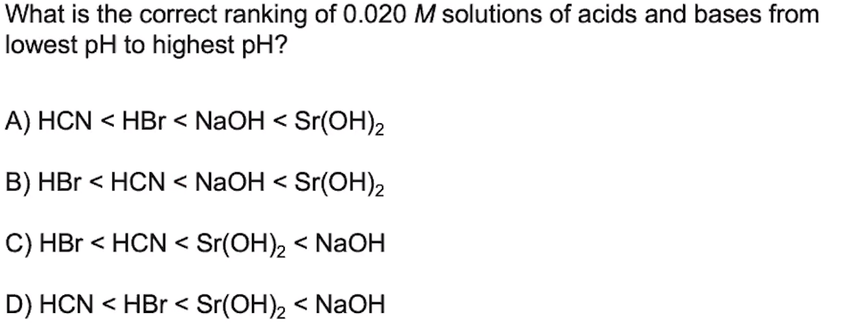
2. **Evaluate how well you answered this question and identify any errors you made.**