**AP Chemistry Daily Videos**

[**8.3 Weak Acid and Base Equilibria**](https://apclassroom.collegeboard.org/7/home)

[**Video #1**](https://apclassroom.collegeboard.org/7/home?apd=v658mbftqs)

1. **Did you make any errors doing this problem? If so, what were they?**
2. **Explain why percent ionization increases as molarity decreases (due to dilution) in terms of Le Châtelier’s Principle.**

[**Video #2**](https://apclassroom.collegeboard.org/7/home?apd=f4em9tc26v)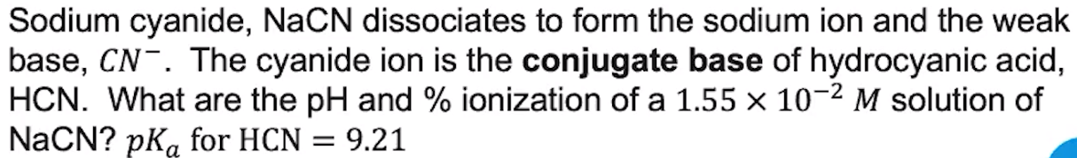

1. **Did you make any errors doing this problem? If so, what were they?**
2. **Did you make any errors doing this problem? If so, what were they?**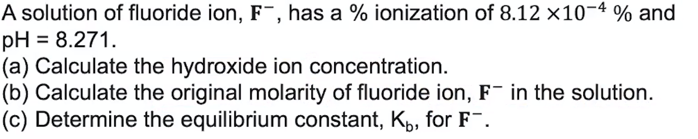
3. **Write down the summarizing points you think are the most important.**

[**Video #3**](https://apclassroom.collegeboard.org/7/home?apd=9bcmqioa0y)

1. **What mental math tips were shared with you?**
2. **Did you make any errors doing this problem? If so, what were they?**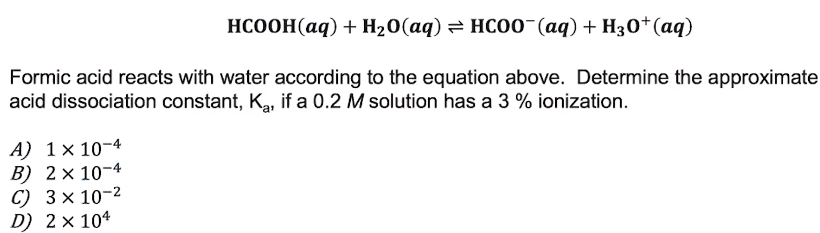
3. **Did you make any errors doing this problem? If so, what were they?**