**AP Chemistry Daily Videos**

[**8.5 Acid-Base Titrations**](https://apclassroom.collegeboard.org/7/home)

[**Video #1**](https://apclassroom.collegeboard.org/7/home?apd=5p4r0nueox)

1. **What is the purpose of doing a titration reaction?**
2. **Label the components in a titration. Be sure to describe the purpose of each part.**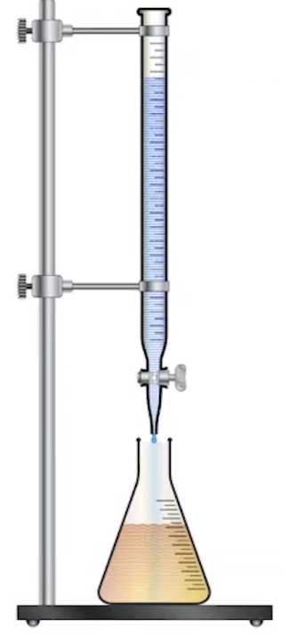
3. **What is the point of the indicator and what should you consider when choosing an indicator?**



1. **Label the important parts on this curve.**

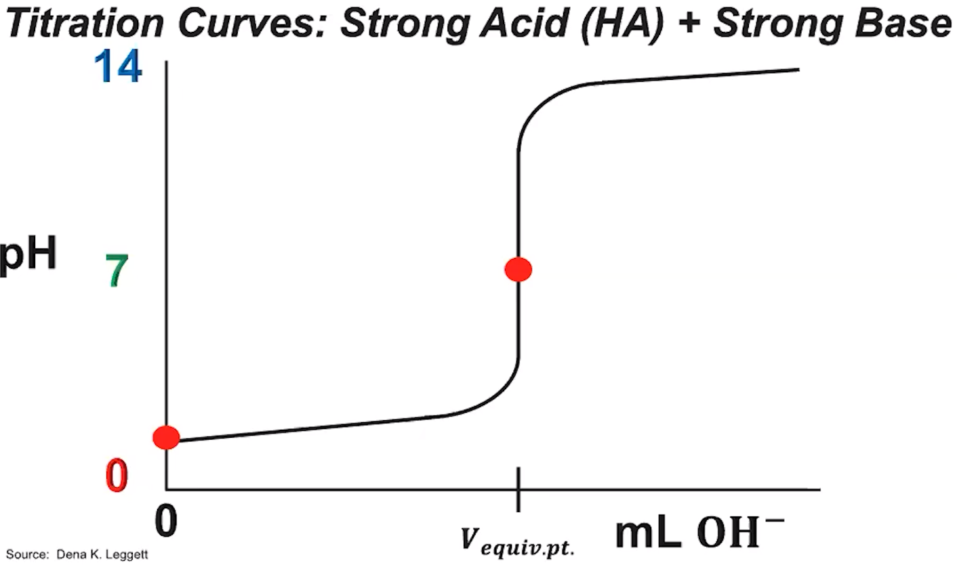

1. **Take notes in how the instructor solved this problem.**



1. **Label important parts of this curve.**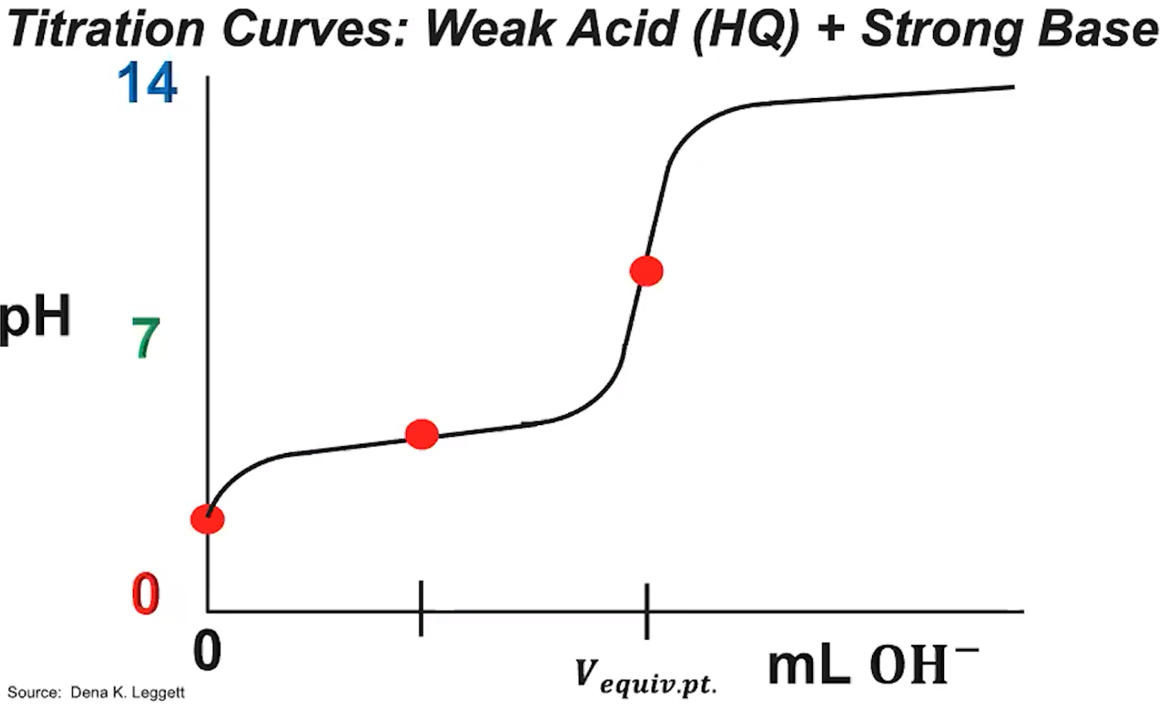
2. **Summarize the most important points at the end of this video.**

[**Video #2**](https://apclassroom.collegeboard.org/7/home?apd=vmasjb5opx)

1. **Label the important parts of this curve.**

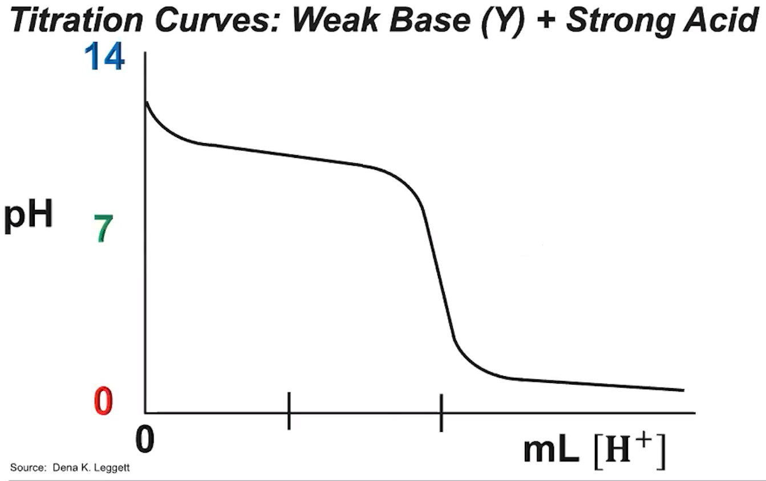

1. **Complete the following problem and evaluate your work.** 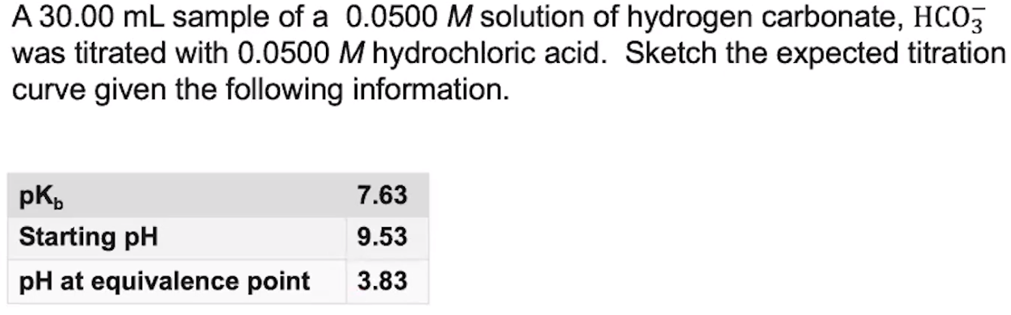
2. **Summarize the most important points at the end of this video.**

[**Video #3**](https://apclassroom.collegeboard.org/7/home?apd=exyq4h4pc3)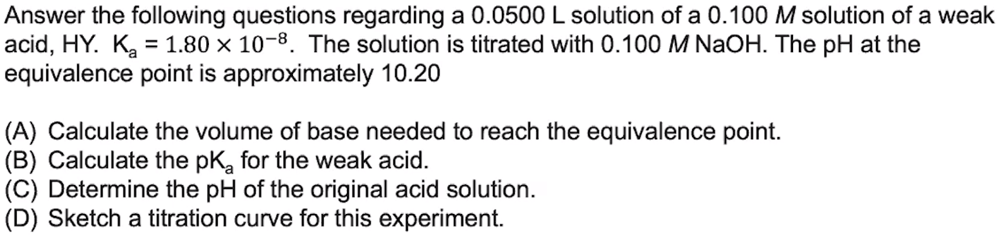

1. **Complete the following problem and evaluate your work.**
2. **Complete the following problem and evaluate your work.** 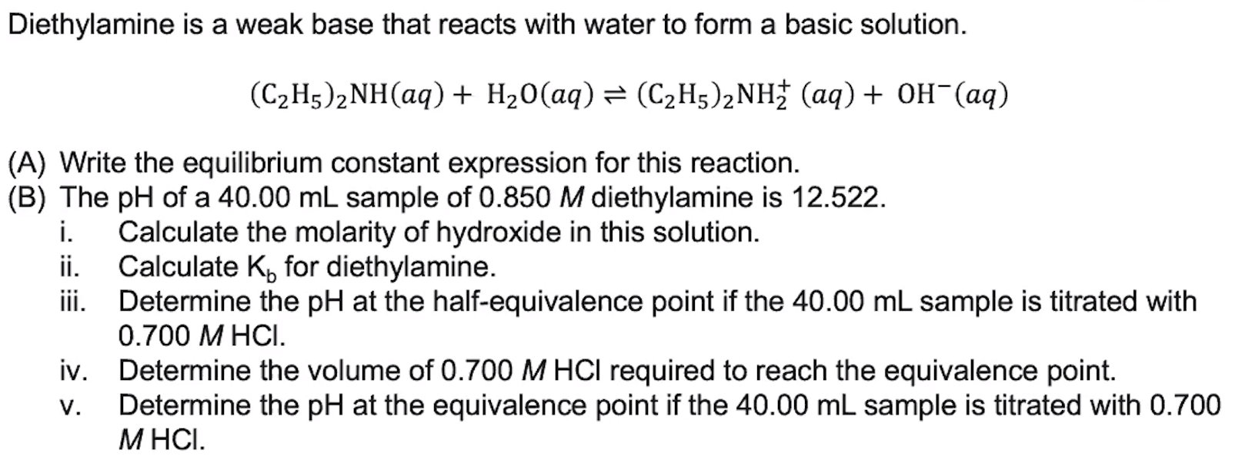

1. **Complete the following problem and evaluate your work.**