**AP Chemistry Daily Videos**

[**8.6 Molecular Structure of Acids and Bases**](https://apclassroom.collegeboard.org/7/home)

[**Video #1**](https://apclassroom.collegeboard.org/7/home?apd=v14cdw43pl)

1. **How easily do strong acids dissociate from H+ compared to weak acids?**
2. **Describe the difference in bond strength between strong acids and weak acids. Use the image below to guide you.**



1. **What role do oxygen atoms play in strong acids? Make sure you include polarity in your answer.**
2. **Evaluate your work.**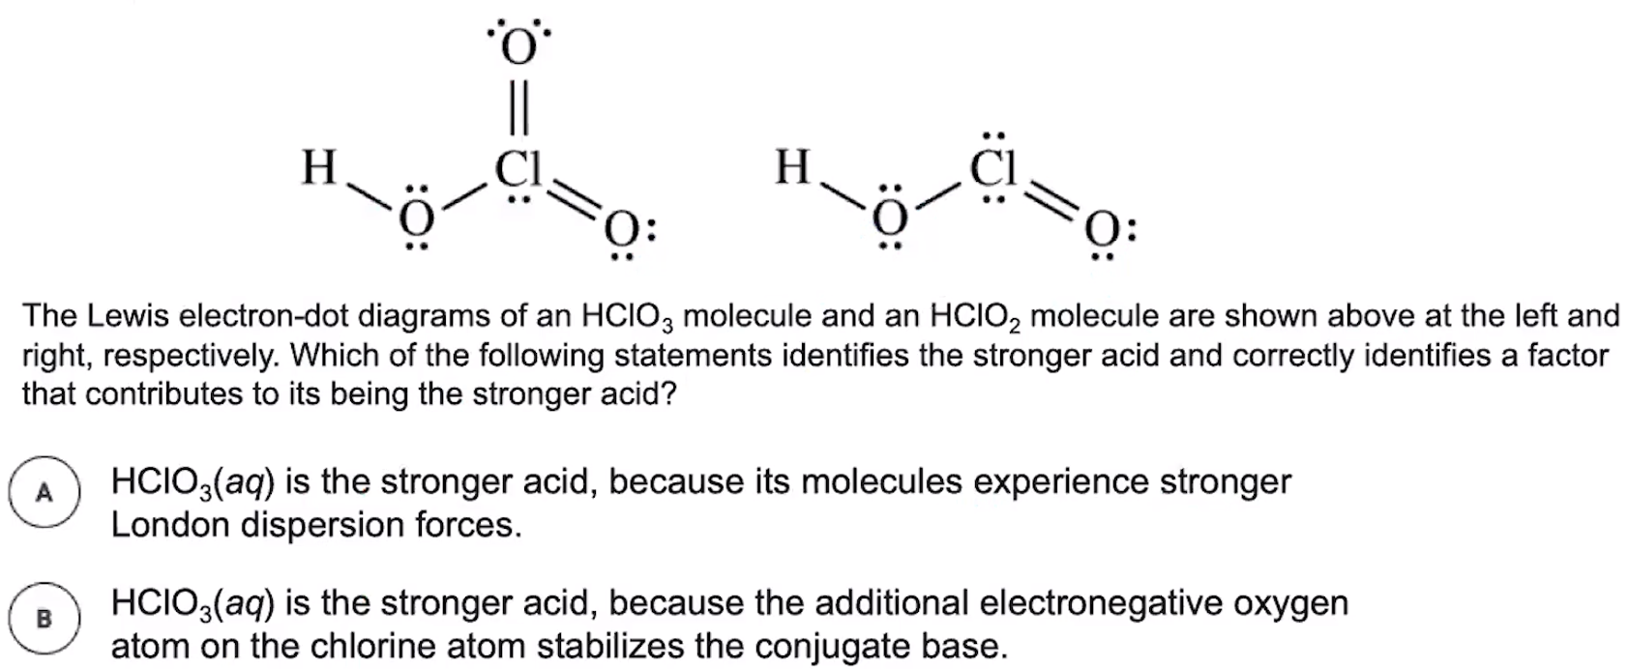
3. **Evaluate your work.**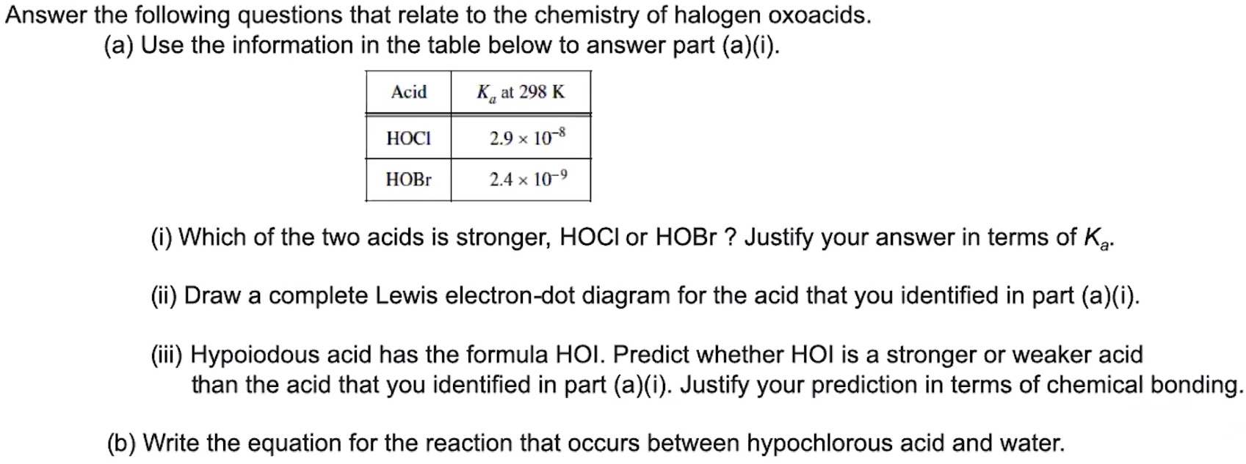

1. **What is the relationship between strong acids and their conjugate bases?**



[**Video #2**](https://apclassroom.collegeboard.org/7/home?apd=vxpc9hjcd7)

1. **What two factors impact whether a species is a strong base?**
2. **Evaluate your work.**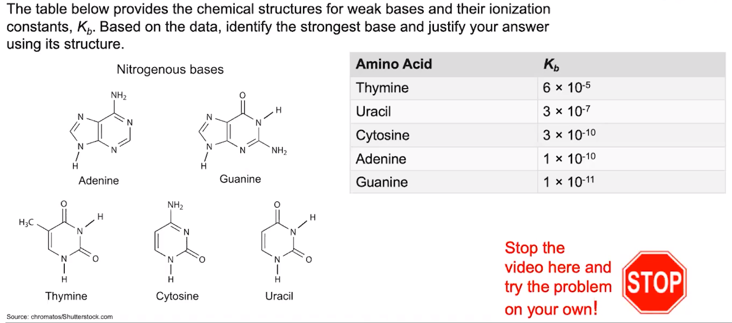
3. **What is the relationship between strong bases and their conjugate acids?**