**AP Chemistry Daily Videos**

**9.1 Introduction to Entropy**

[**Video #1**](https://apclassroom.collegeboard.org/d/4xxl2f68xj?sui=7,9)

1. **What is the definition of entropy?**
2. **What are the situations where entropy increases?**
3. **Pause the video @ 2:26 and try the problem on your own. Then evaluate your work and identify any errors you may have made.**

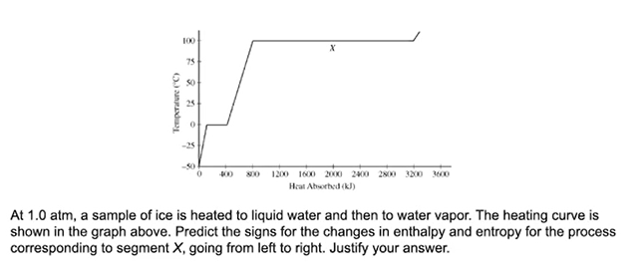

1. **Pause the video @ 3:25 and try the problem on your own. Then evaluate your work and identify any errors you may have made.**

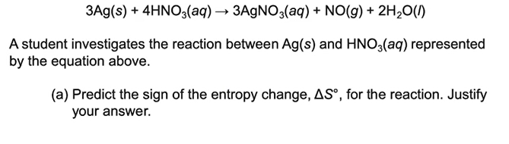

1. **What are the key takeaways?**