**AP Chemistry Daily Videos**

**9.3 Gibbs Free Energy and Thermodynamic Favorability**

[**Video #1**](https://apclassroom.collegeboard.org/d/rayaifew2f?sui=7,9)

1. **What is Gibbs free energy?**
2. **What does ΔGº represent?**
3. **What values of ΔGº indicate a thermodynamically favorable process?**
4. **What is the equation used to calculate ΔGº for a reaction?**
5. **Pause the video @ 3:55 and try the problem on your own. Then evaluate your work and identify any errors you may have made.**

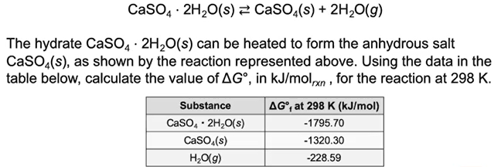

1. **What are the takeaways?**

[**Video #2**](https://apclassroom.collegeboard.org/d/r80jeziwxa?sui=7,9)

1. **What is the equation used to calculate the Gibbs free energy based on both entropy and enthalpy?**
2. **Complete the table with the temperature conditions necessary for a process to be thermodynamically favorable.**

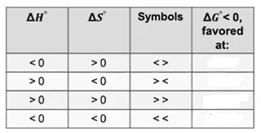

1. **Under which circumstances is a calculation for ΔGº necessary to determine favorability?**
2. **Pause the video @ 4:55 and try the problem on your own. Then evaluate your work and identify any errors you may have made.**

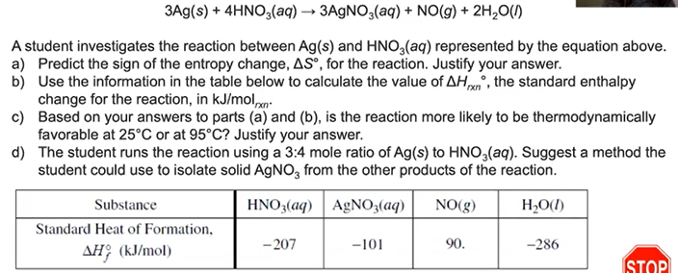

1. **What are the takeaways?**